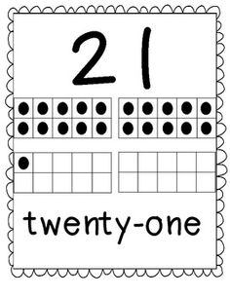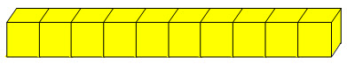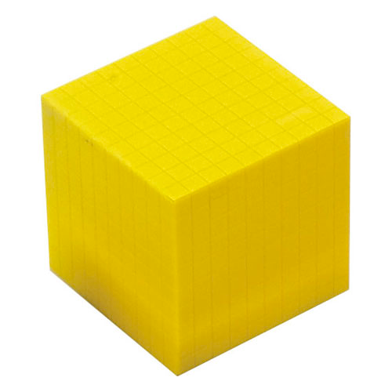

5+5+5+5+1= 21

10⍧ + 10 ⍧ + 1 ⍧= 21⍧

What is partitioning?

Partitioning is when you break a number apart. Below are some examples, using the number 21, of what students in grade 2 need to do when partitioning.

Writing number expressions:

10+10+1= 21 20+1= 21

31-10=21 25-4= 21

Using tally marks:

Using ten frames:

Using coins (pennies, dimes, nickels, and quarters)

Using Base 10 blocks (not until second term)

Solving word problems:

Chris was collecting hockey cards. He had some Jacob gave him 12 more. Chris now has 21 cards. How many cards did Chris have to start?