I can identify the core of a repeating pattern

Lesson Plan Title

I can identify the core of a repeating pattern

Lesson Summary

Students are expected to identify, extend, and name a variety of repeating patterns.

Background

In grade one students were introduced to repeating patterns, in grade 2 they are expected to extend their knowledge of patterning to include patterns that involve up to 5 elements, label using letters, and change from one mode to another (ie: using sound, diagrams, and actions).

Curriculum Outcomes

PR01- Students will be expected to demonstrate an understanding of repeating patterns (three to five elements) by describing, extending, comparing, and creating patterns using manipulatives, diagrams, sounds, and actions.

Assessment Of Learning or Assessment For Learning

Observation, Conversation, Product

Observations
- Can students identify a repeating pattern?

Conversations
- Can students explain the repeating pattern used?

Product
- Can students complete the activities at each math station-to help extend their knowledge of what the core of a pattern is.
Communication/Vocabulary

- Repeating pattern
- Extend
- AB (letter) pattern
- Core, element
- Mode
- Pattern Rule
- Describe
- Compare

Technology

- iPad’s (if required)
- Smart Note book software

Materials

- Markers
- White paper
- iPads
- Pattern Blocks
- Unifix Cubes
- I can identify the core of the pattern sheet
- Oral Assessment Sheet
- Math Journals: My math journals are the hilroy scribblers where half the page is for writing and half is for drawing. It looks something like this.

Mental Mathematics

Have students subtract using 0. Count forwards and backwards by 1’s, 2’s, 5’s and 10’s.

Development

Students will be expected to understand what the core of a pattern is. Through math stations they will develop and extend their knowledge of patterns with a focus on identifying the core of a pattern and extending patterns once they know the core.

Time To Teach

Activate prior knowledge by drawing on a white board or on smart note book software
-Square, triangle, circle, square, triangle, circle, square, triangle, circle.

Ask students to think-pair-share what the CORE of the pattern might be (students may not be accurate and that is okay). After about 2 minutes of sharing, have students come back and share what they think the core might be. If a student has the correct answer (the first set of square, triangle, circle) have them circle it. Explain to students that today they are going to work at a variety of stations to identify the core of a pattern and then extend the pattern using manipulatives. Some of these will be worksheets and some will be hands on a combination of both allows you to easily see what students can do.

Time to Practice

Stations- I usually only have 2 Students per station-if you have to have more, don’t go higher then 3

1. Create a pattern using pattern blocks create a pattern, trace the pattern and colour it in label the pattern EXAMPLE and put in a sheet protector (make at least 12 patterns).
-At this station students will be given white board markers and be asked to first circle the core of the pattern they are looking at using the white board marker on top of the sheet protector
-Then have students use pattern blocks to extend the pattern using pattern blocks

2. iPad Station 1- Pattern Shapes App (free)- 2iPads

For more information: http://www.mathlearningcenter.org/blog/pattern-shapes-app

At this station students will create a pattern on the app
-Using the white board function have the students circle the core of the pattern
-Have students take a picture of their pattern (with the core circled) have them print it off to be handed in for assessment

3. Unifix cubes station- have at least 12 patterns built and taped to the area where students will be working.
-Have students identify and build the core of the pattern using their own unifix cubes
-If students get through all 12 patterns quickly have them build their own pattern and have their partner determine what the core of the pattern is.

4. Marker Station

Have white paper and markers available at this station
-At this station have students create a pattern using the markers- then have them circle the core of their pattern.
-Tell students they must have at least one pattern using colours, one pattern using shapes, and one pattern using letters. (this extends their knowledge of patterning)

5. Math Journal Station

Have math journals available at this station
-Have students create a pattern
-Have them circle the core of the pattern
-Ask them to write an explanation of how they know this is the core of the pattern

6. Worksheet station- I can identify the core of a pattern station

Provide students with the sheet I can identify the core of a pattern
-Have students complete the worksheet

7.Teacher Station

Oral Assessment at the teacher station
-Show students a pattern (unifix cubes, pattern blocks) have students TELL you what the core of the pattern is
-Have students extend the pattern

8.Smartboard station (I will explain how to set this up)-Please note that my students use a finger pointer to use the smartboard

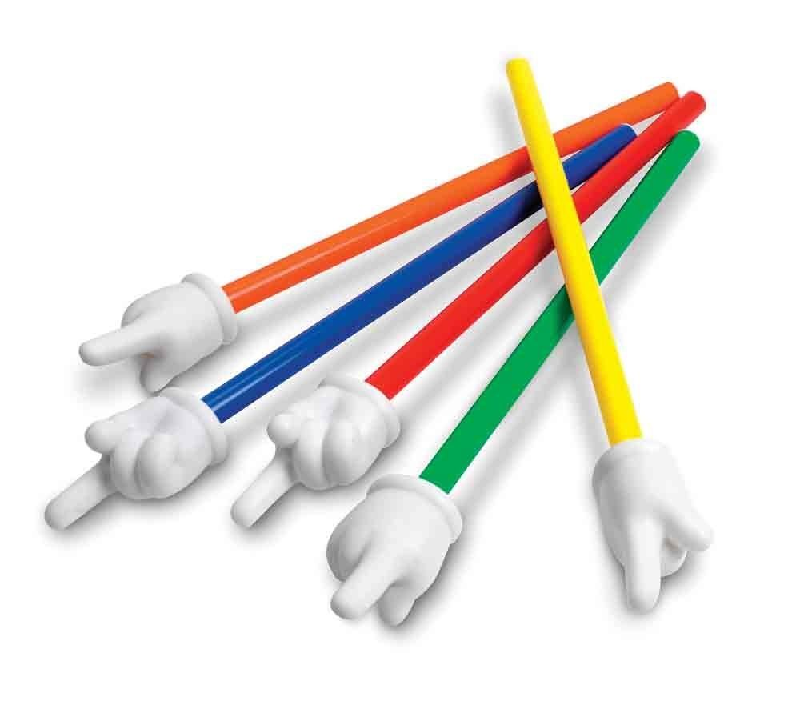
-Go into the gallery and search “pattern blocks”
-Place each pattern block once onto the smart notebook screen (make smaller if necessary)
-On the arrow drop down menu click on infinite cloner

At the station:
-Have students create a pattern have their partner circle the core

9.iPad station 2- Pattern Shapes App- 1 iPad

For more information: http://www.mathlearningcenter.org/blog/pattern-shapes-app

At this station students will create a pattern on the app
-They will have their partner circle the core of the pattern-they will double check the work
-If correct then the partner creates a pattern

10. Pattern Blocks station 2

Have privacy folders at this station you can easily make these by stapling 3 manila folders together
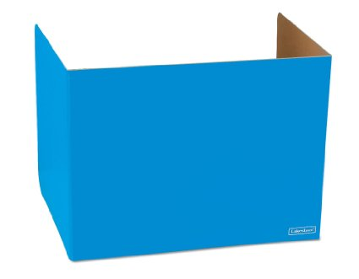

Have students build a repeating pattern behind the privacy folder
-Then have them lift their folder
-The partner then orally tells what the core of the pattern is

Time to Share

Students will share one of the stations they completed and explain how they identified the core of the pattern.

Differentiation

- For students who struggle to find the core of the pattern have them start at the teacher station.

I can identify the core of the pattern

Name: _________________________

Circle the core of the pattern and extend the pattern

________ _________

Circle the core of the pattern

Circle the core of the pattern, draw in the missing element

___________

Using the core of the pattern, extend the pattern

_______ _______ _______ _______ _______

Create your own pattern and circle the core

Teacher Oral Assessment

Student Name: ____________________

Show students a pattern using unifix cubes (red, green, green, blue, red, green, green, blue)
-Have students identify the core of the pattern through speaking
-Have students extend the pattern using unifix cubes

Expectations | Check if they complete expectations | Anecdotal Notes
Student identified the core of the pattern orally

Student extended the pattern using unifix cubes

