How the Traffic Light Works

1. Print off on photo paper (I prefer matte because you can scratch colour off of the shiny stuff)

2.Hang on a magnetic surface

3.Print off coloured lights twice- one to hang up with the traffic light one to cut the colours out

4. Put a magnetic strip on the back of each cut out colour

5. Teach students what each colour means

6. When teaching/independent work time put up the colour that it is in the classroom (ie: If you want complete quiet you would put up the red traffic light)

7. Whenever you hang up a colour remind your students of the expectation for that colour so they know what you are expecting

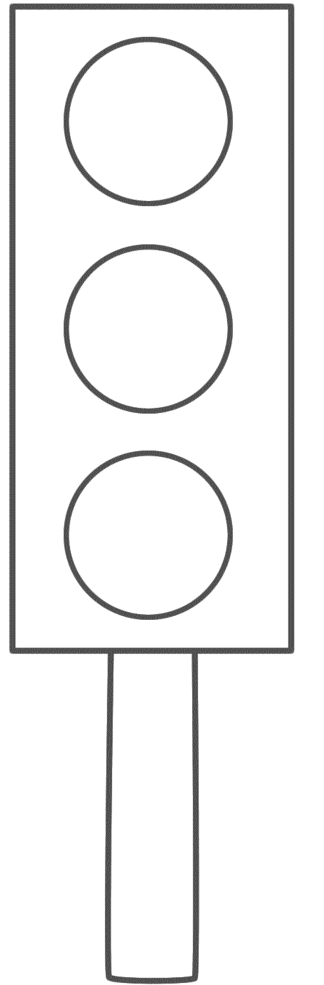
Green

Indoor Voices- Partner work time
Yellow

Whisper Voices- Quiet work time

Red

No talking- silent work time

