I can create subtraction number expressions using part part whole

Lesson Plan Title

I can create subtraction expressions using part part whole.

Lesson Summary

Students will be expected to use the part part whole strategy to create number expressions

*Please note that this is an introductory lesson-by the end of the year students should be able to use the part part whole strategy to solve a wide variety of problems.
Curriculum Outcomes

N04- Students will be expected to represent and partition numbers to 100
Performance Indicator N04.06- Represent a given number using number expressions

Assessment Of Learning or Assessment For Learning

Observation, Conversation, Product

Observations
- Do students use the part part whole strategy during mental math to represent numbers?

Conversations
- Can a student explain why using part part whole helps them solve subtraction problems?

Product
- Can students use the part part whole strategy in their math journal to represent a number and solve subtraction problems.
Communication/Vocabulary

- Part part whole
- Partition
- Subtraction, take away, minus, less then
- Number Expression
- Math Journal

Technology

- I can create number expressions using part part whole Key Note Presentation
http://jkeithgrade2mathns.weebly.com/partitioning.html
- iPads (show me APP)

Materials

- Part Part Whole (see below)
- Markers
- Sticky Notes (Post It Notes)
- Smart board (smart interactive technology)
- Example of a part part whole- One of my students this year recognized the wall was an example of part part whole. I made digit cards and would attach them onto the wall when using examples of part part whole

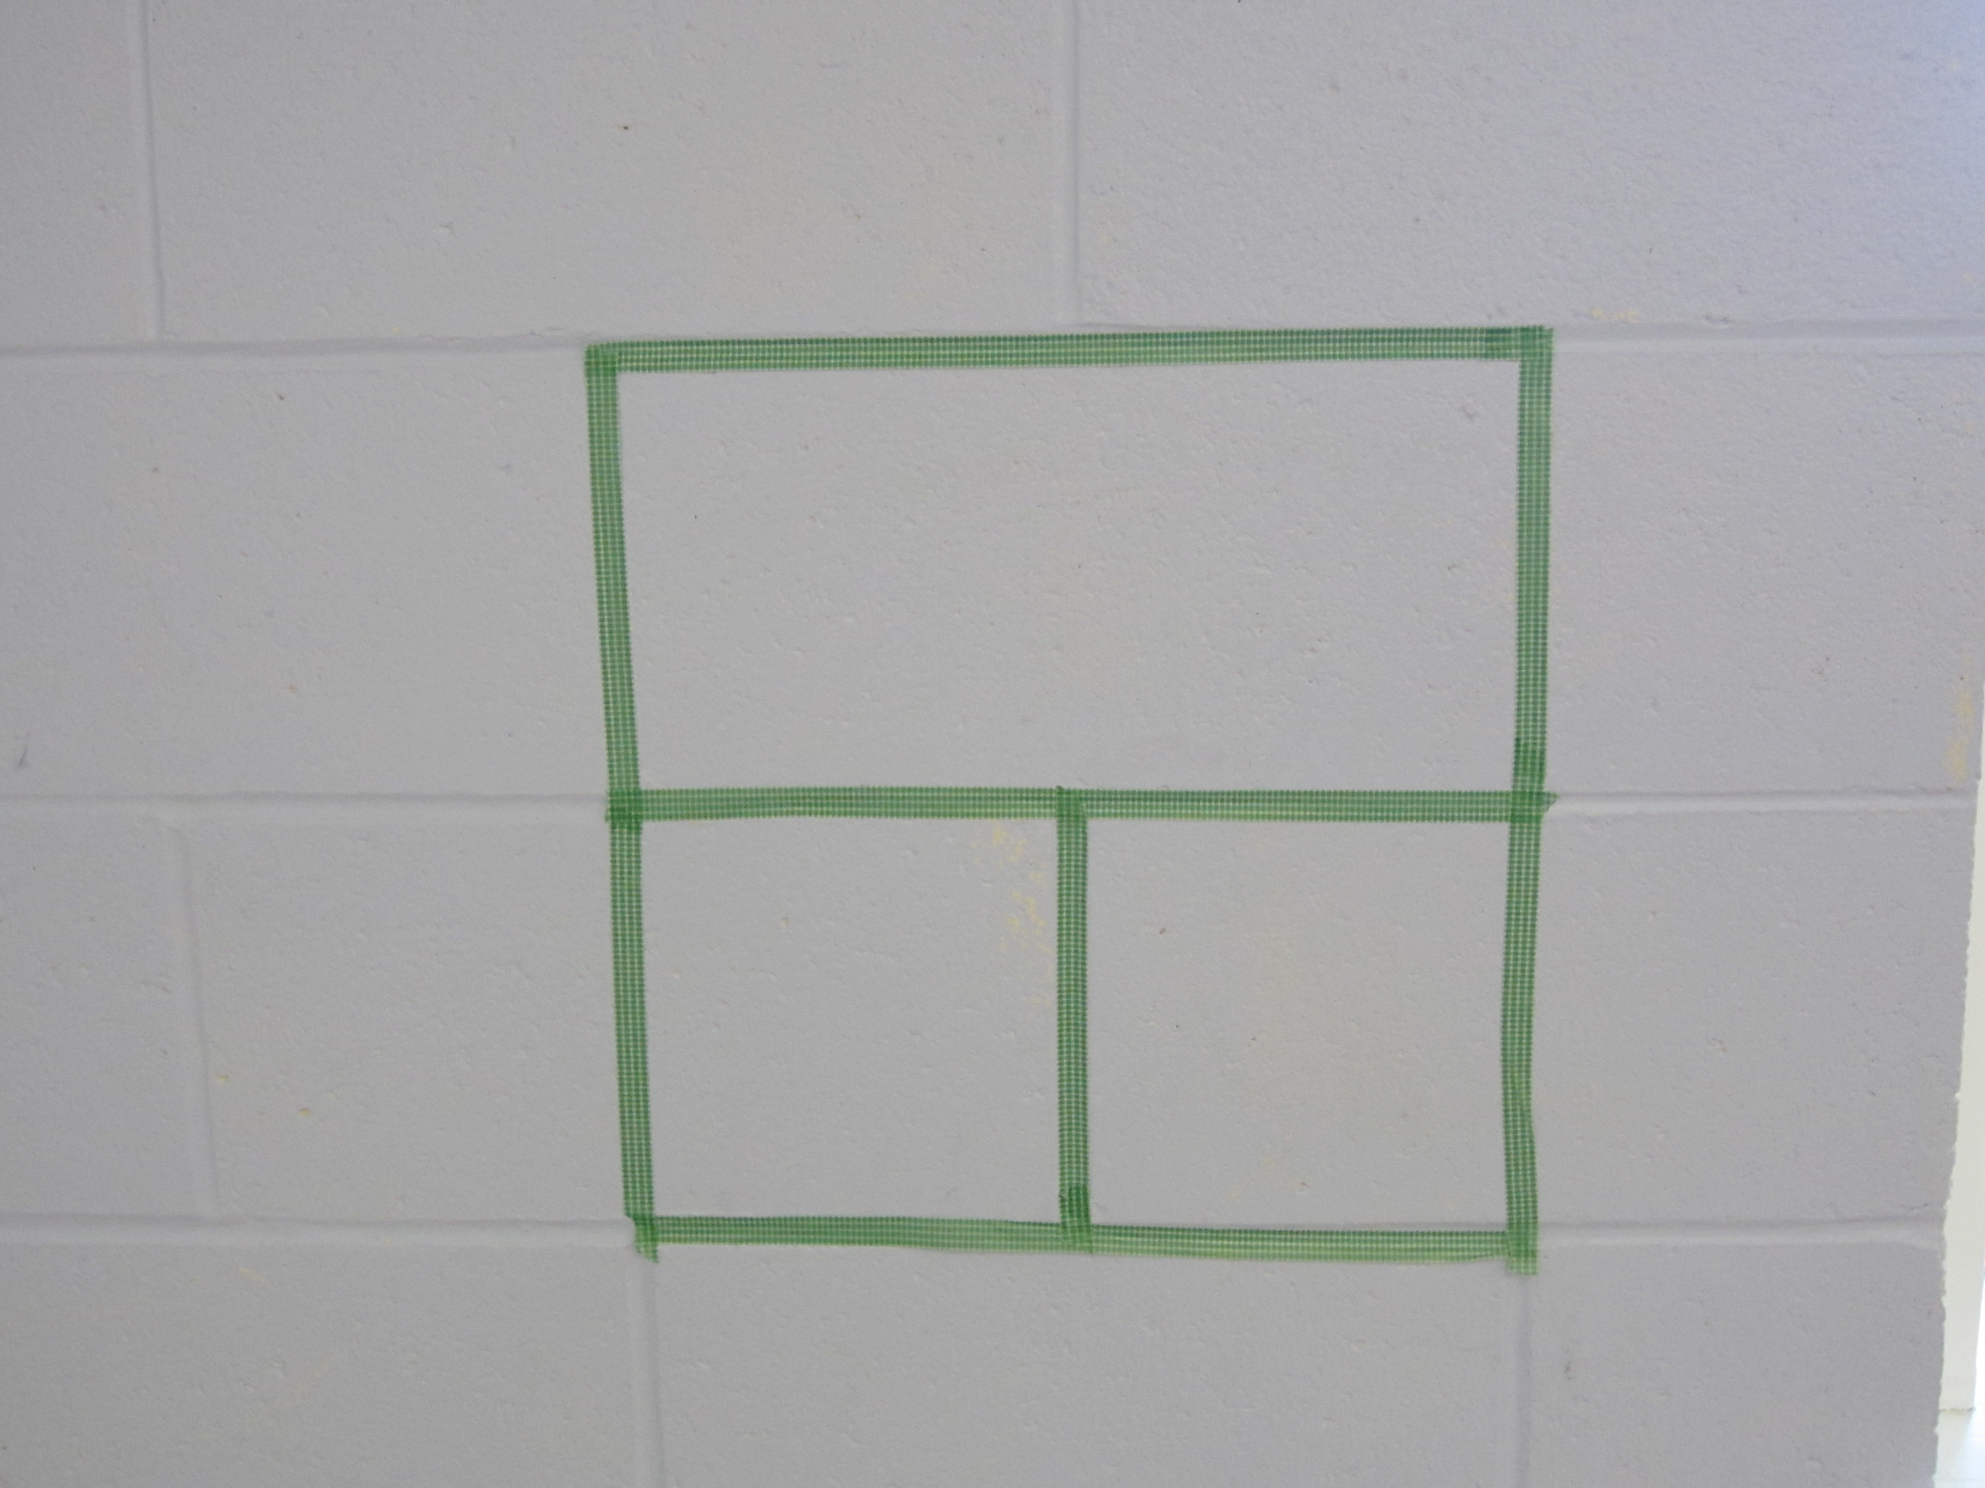

- Math Journal:My math journals are the hilroy scribblers where half the page is for writing and half is for drawing. It looks something like this.

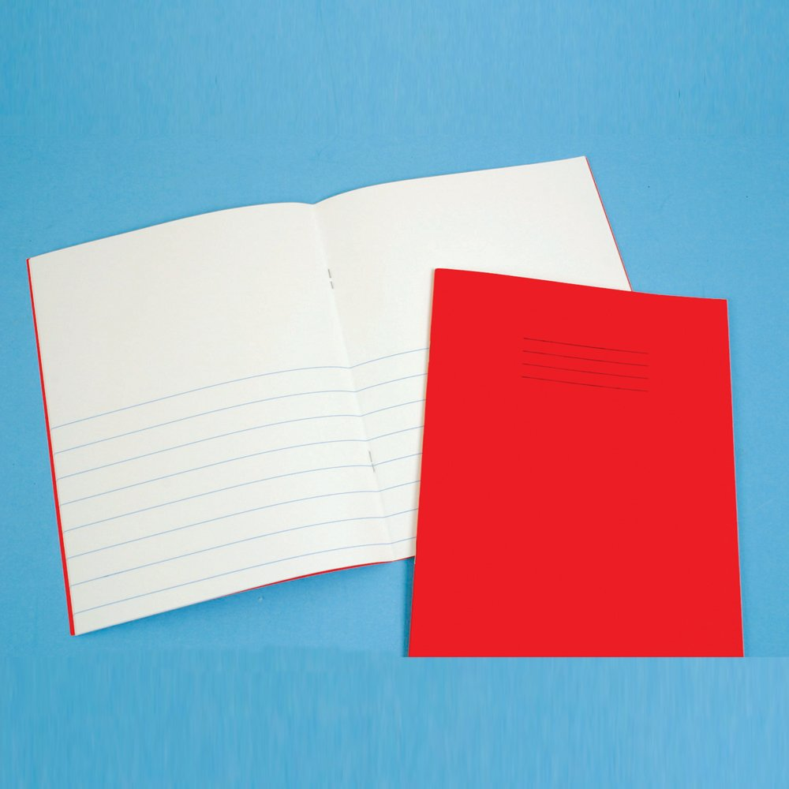

Mental Mathematics

Review addition strategies such as double plus one and relate them to subtraction facts
Review addition strategies such as adding to 10 and relate them to subtraction facts
Review subtracting 0 from numbers. (ie: 10-0=10)

Time To Teach

Activate prior knowledge by putting a blank part part whole on the board (I use the smart board for this). In grade one the students should have use part part whole as a strategy when working with numbers to 20. Ask the students if they can explain what this is and how it is used for subtraction.

*If not you may want to watch the Key Note presentation I can create number expressions using part part whole Key Note Presentation
http://jkeithgrade2mathns.weebly.com/partitioning.html
Time to Practice

Once students have gone through the review of how to use a part part whole to show subtraction hand them a sticky note have them choose a number from 20-50.

Have students write their choosen number on their sticky note (you can easily see who is writing numbers backwards etc).

Then have students either draw or cut out a part part whole (see below) to put in their math journals and use it to show subtraction. (ie: in subtraction we have the whole and one part, we take the part away from the whole to find the other part).

Time to Share

When students have finished they may share their work as a small group at tables OR as a whole class. I would usually have them share as small groups to double check their work. Some students may choose to do more then one part part whole.

Tech Integration
Using the show me interactive white board App may be a way that some students choose to share their work.
They can record their information using the white board tools.
For more information: http://www.showme.com/
Differentiation

- For students who struggle start with numbers 1-9 and move up from there.
- For students who struggle a guided math group may be required
- For enrichment have students use the same number and create more then one part part whole OR have them choose a larger number.

Part Part Whole
Part

Whole | whole

Part Part Whole
Part

Whole | whole

