I can solve addition story problems using part part whole

Lesson Plan Title

I can solve addition story problems using part part whole

Lesson Summary

Students are expected to use personal strategies to solve a wide variety of story problems

Curriculum Outcomes

N04- Students will be expected to represent and partition numbers to 100
Performance Indicator N04.06- Represent a given number using number expressions
N09- Students will be expected to demonstrate an understanding of addition (limited to 1- and 2- digit numearls) with answers to 100 and the corresponding subtraction
Performance Indicator- N09.01- Solve a given story problem of any type by modelling it with materials or a diagram and write a number sentence that represents the thinking in the solution.

Assessment Of Learning or Assessment For Learning

Observation, Conversation, Product

Observations
- Can students use part-part-whole to solve a wide variety of story problems?

Conversations
- Can a student explain why they might use part part whole to solve a story problem?

Product
- Can students demonstrate that they have used part part whole to solve the story problems on the story problem sheet below?
Communication/Vocabulary

- Part part whole
- Partition
- Addition, add, plus, more then
- Number Expression (formally Number Sentence)

Technology

- Key Note Presentation I can add using part part whole
http://jkeithgrade2mathns.weebly.com/problem-solving.html

- iPads (PaperPort Notes App, Show Me App, K-2Math Tools App)

Materials

- Part Part Whole sheet
- I can solve story problems using part part whole sheet (please note that I use local examples and my own students’ names along with interests in my story problems)
- Counters ( if needed)
- Sticky Notes (Post It Notes)
- Example of a part part whole- One of my students this year recognized the wall was an example of part part whole. I made digit cards and would attach them onto the wall when using examples of part part whole

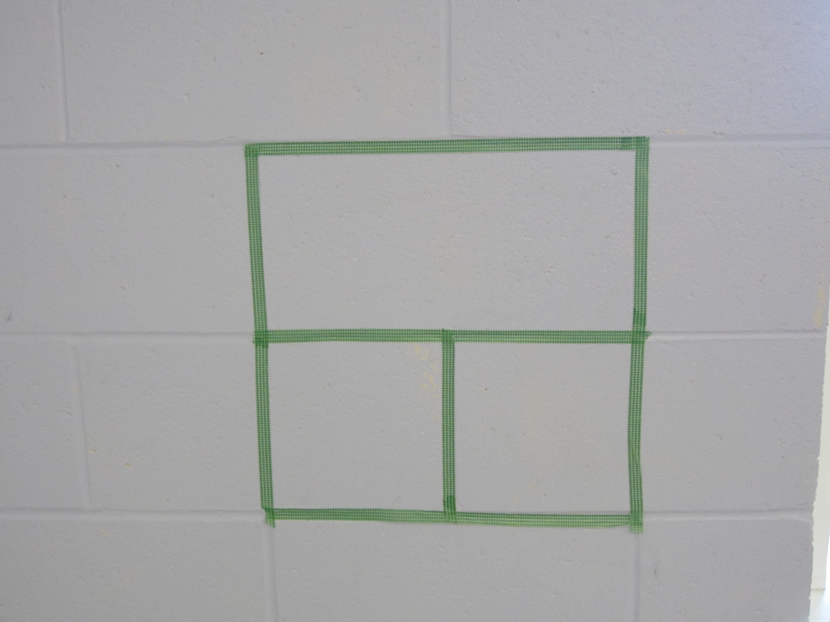

Mental Mathematics

Review addition strategies such as double plus one
Review addition strategies such as adding to 10
Review adding using 0 (ie: 10+0= 10)

Time To Teach

Activate prior knowledge by putting a blank part part whole on the board (I use the smart board for this). In grade one the students should have use part part whole as a strategy when working with numbers to 20. Ask the students if they can explain what this is and how it is used.

If not go through an example- In the top section we put in the whole number in the bottom section we put two numbers that add up to the whole number. The show them how to create a number expression out of that. For example: 22=11+11

Then watch the Key Note Presentation I can add using part part whole http://jkeithgrade2mathns.weebly.com/problem-solving.html

Time to Practice

Hand students the part part whole sheet with sticky notes (I use sticky notes because students can write the numbers on them and throw them out afterwards meaning we can reuse the part part whole sheets more times).

Hand out the I can solve problems using part part whole sheet. Tell students they will be working independently to solve these problems for about 20 minutes. If they do not understand after 20 minutes you will help. During this time I would allow the students to collaborate to help one another.

Time to Share

Students will share their answers in small groups and discuss what was the same and what was different. Students will compare their answers and share how they came to the answer. Ask students during this time if they are going to change their answers to use a marker or pencil crayon so you can compare what they had to what they have changed to.

Tech Integration

Using the PaperPort Notes App students can take a picture of the part part whole sheet and complete it using the App.
For more information: http://www.paperportnotes.com/

Some students may choose to show their work using the Show Me App, they can use it like a white board.

For more information: http://www.showme.com/

Some students may need to use the App K-2 Math Tools App this app has a 10X10 Addition Grid which may be easier for students who struggle to solve addition problems in their head (mostly for students identified with working memory problems).

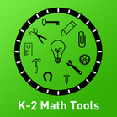

For more information: https://itunes.apple.com/us/app/k-2-math-tools/id1000444174?mt=8

Differentiation

- For students who struggle you may need to change the numbers in the problems to be smaller numbers
- Students who struggle may also require a guided math group to help solve problems
- Students who require enrichment may need to work with bigger numbers
- Students who finish early should be asked to write their own story problem that others’ in the class will solve

Part Part Whole

I can solve addition problems using part-part-whole
Name: ____________________________________

Jackson was playing hockey and he scored 2 goals in the game, his teammate Jordan scored 4 goals in the game. How many goals did Jackson and Jordan score altogether?

Olivia was playing Mario Kart she had 23 coins, then she collected 13 more coins. How many coins did Olivia have at the end of the game?

Challenge question: Meredith baked cookies for the class she baked 25 cookies. In our class there are 12 girls and 9 boys. Are there enough cookies for everyone?

