**I can read and use a calendar**

|  |
| --- |
| **Lesson Plan Title**  I can read and use a calendar |
| **Lesson Summary**  Through a guided lesson, students will learn to read the months of the year and say them.  *Please note I usually don’t start this lesson until I have proof that students know the months of the year |
| **Curriculum Outcomes**  M01- students will be expected to demonstrate an understanding of the calendar and the relationships among the days, weeks, months and years. |
| **Assessment Of Learning or Assessment For Learning**  Observation, Conversation, Product  Observations   * Can students write the month properly? * Can students say the date , including the month properly? * Can students determine what month it is? Can students determine what month will come next? Can they answer questions about the month (for example: If this month is December which is 2 months from now?)   Product   * Can students put the months of the year in order? * Can students |
| **Communication/Vocabulary**   * Calendar * Month * Year * Date * Ordinal numbers (ie: first, second etc.) |
| **Technology**   * You Tube Video- Months of the Year   <https://www.youtube.com/watch?v=5enDRrWyXaw> |
| **Materials**   * Wipe on wipe off calendar * White board markers * Months of the year video * Months of the year worksheets taken from <http://www.worksheetfun.com> |
| **Mental Mathematics**  Ask some calendar questions to asses prior knowledge.  If this month is April what is next month? What was last month?  If today this month is September how many months until Remembrance Day? How many months until summer holiday?  *While students answer look for students who seem confused, or unsure and make a note of this. |
| **Development**  Play the months of the year song- maybe twice. I don’t use the video I teach them the song and we sing it twice through on a daily basis until students are comfortable answering questions about the months of the year.  **Time to TEach**  Talk to the students about the calendar, ask them if they know of any important months, that have holidays. Students love to share what month they are born in, but they will also name major holidays.  **Time to Share**  Ask students to go knee to knee and share one important month to them. Have them share why the month is important. Then have them share what they know about that month. They might share things like the weather of that month, how many months until that month etc. Once students have completed this activity have them share with the class what they have learned.  **Time to Practice**  Have students complete the months of the year activities (see below) to determine their knowledge of the months. |
| **Differentiation**   * Some students may need their Calendar books right away to help them solve calendar problems * More advanced students will need harder questions. How many months since you have left grade one? How many months until Easter? |

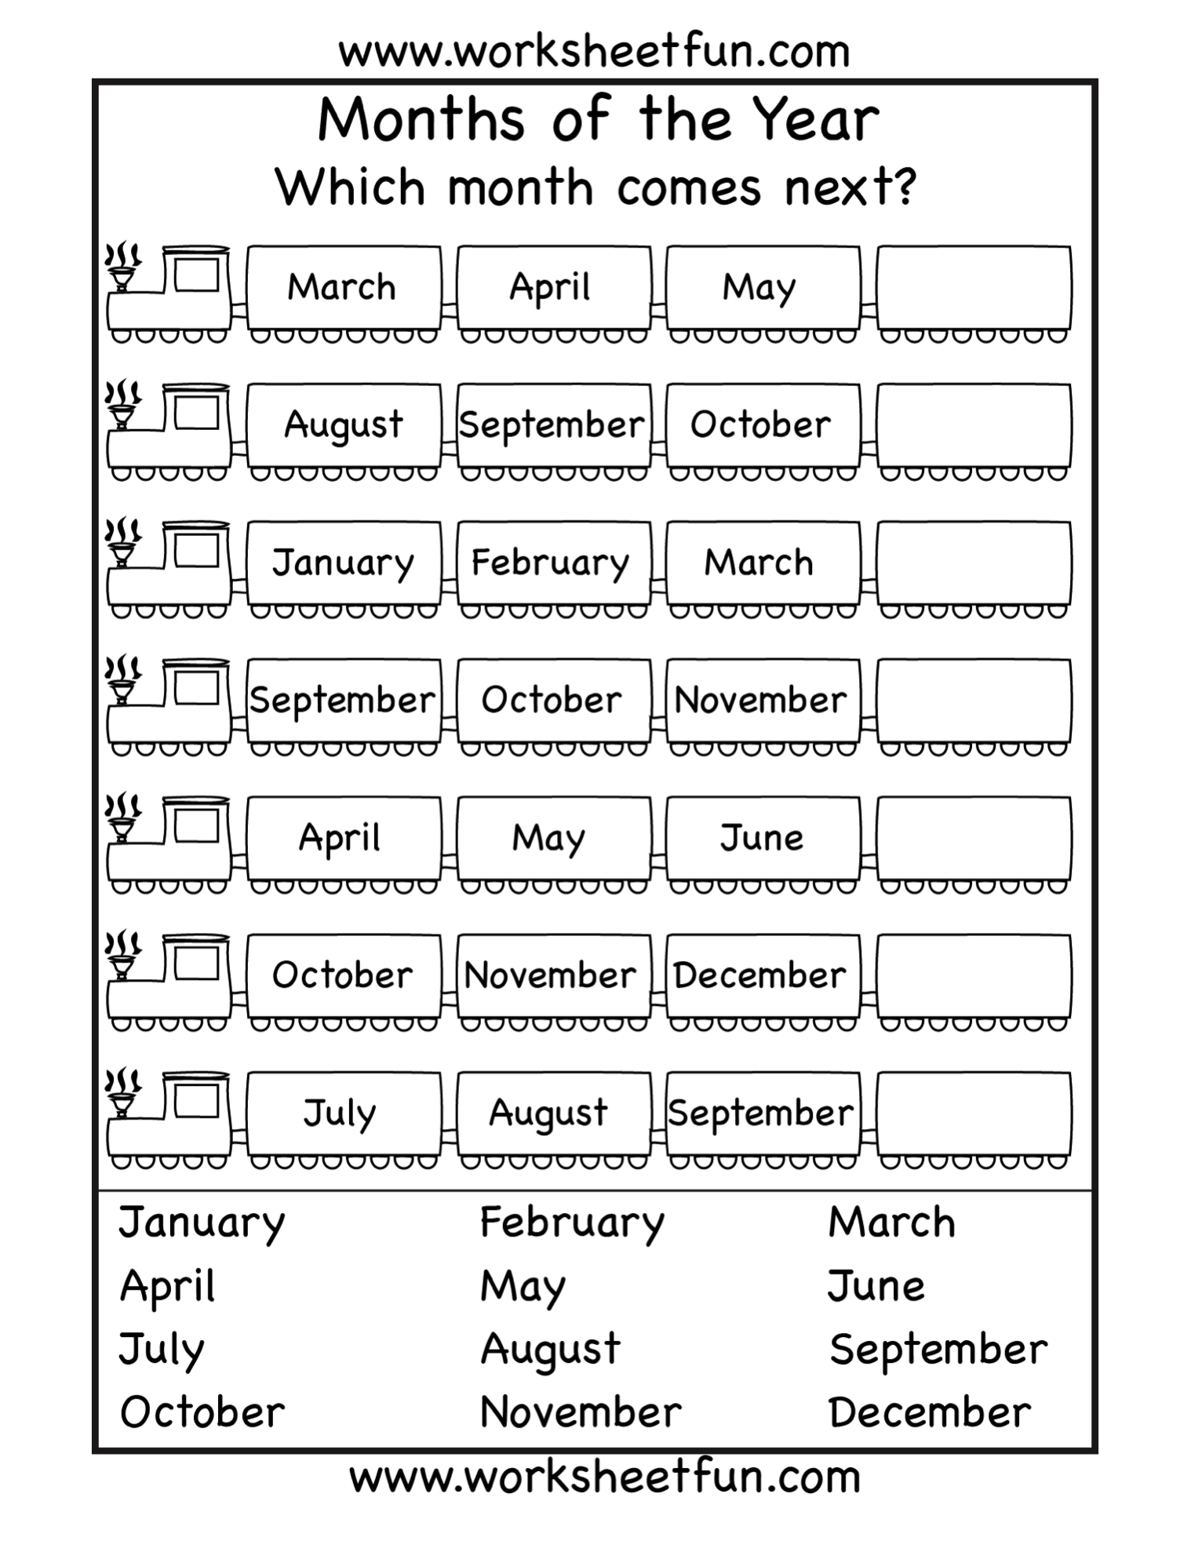

Thaw Space:ssrsb:Downloads:monthsoftheyearworksheetfun4.pdf

Thaw Space:ssrsb:Downloads:monthsoftheyearworksheetfun1.pdf