**I can name the days of the week**

|  |
| --- |
| **Lesson Plan Title**  I can name the days of the week. |
| **Lesson Summary**  Through a guided lesson, students will learn about the calendar and how we use it. I use this lesson at the beginning of each month again.  \* Please note that while this is the initial lesson you will continue to use the calendar everyday for mental math and scheduling activities. |
| **Curriculum Outcomes**  M01- students will be expected to demonstrate an understanding of the calendar and the relationships among the days, weeks, months and years. |
| **Assessment Of Learning or Assessment For Learning**  Observation, Conversation, Product  Observations   * Can students write the calendar number properly? * Can students say the date properly? * Can students determine what tomorrow will be? What yesterday was? What will be three days from now?   Product   * Could students put the days of the week in order? * Could students unscramble the names of the days of the week? |
| **Communication/Vocabulary**   * Calendar * Month * Year * Date * Days of the week- Monday, Tuesday, Wednesday, Thursday, Friday, Saturday, Sunday |
| **Technology**   * You Tube Video- Days of the Week   <https://www.youtube.com/watch?v=yIvQOab00OQ> |
| **Materials**   * Wipe on wipe off calendar * White board markers * Days of the week * Days of the week ordering sheet (see below)- taken from <http://guruparents.com/> * Days of the week unscramble sheet (see below) taken from <http://guruparents.com/> * Anecdotal recording sheet |
| **Mental Mathematics**  Ask some calendar questions to asses prior knowledge.  If today is Monday what is tomorrow? What was yesterday?  If today is Tuesday how many days has it been since Sunday? How many days until Friday?  Review doubles facts: ie: 7 plus 7, as well as facts that add to 7. 6+1= 7+0 (etc.)  \*While students answer look for students who seem confused, or unsure and make a note of this. |
| **Development**  Play the days of the week song- maybe twice. I don’t use the video I teach them the song and we sing it twice through on a daily basis until students are comfortable answering questions about the days of the week.  **Time to Teach**  Talk to the students about the days of the week. Ask students if they can name the days in order. Some may use their personal calendars (first day of the month lesson plan <http://jkeithgrade2mathns.weebly.com/math-wall.html> )  **Time to Practice**  Once students have talked about the days of the week, and named them in order. Hand them out the days of the week activity sheet  **After**  Have students share and compare their work in whole group lesson. Take notes on the anecdotal evidence sheet of how students used the worksheets. There are three worksheets so the lessons may take more then one day to complete and share.  Thaw Space:ssrsb:Desktop:Math Wall photos:IMG_0813.jpg |
| **Differentiation**   * Some students may need their Calendar books right away to help them solve calendar problems * More advanced students will need harder questions. How many days between Billy Bob’s birthday and the day that we have no school. |

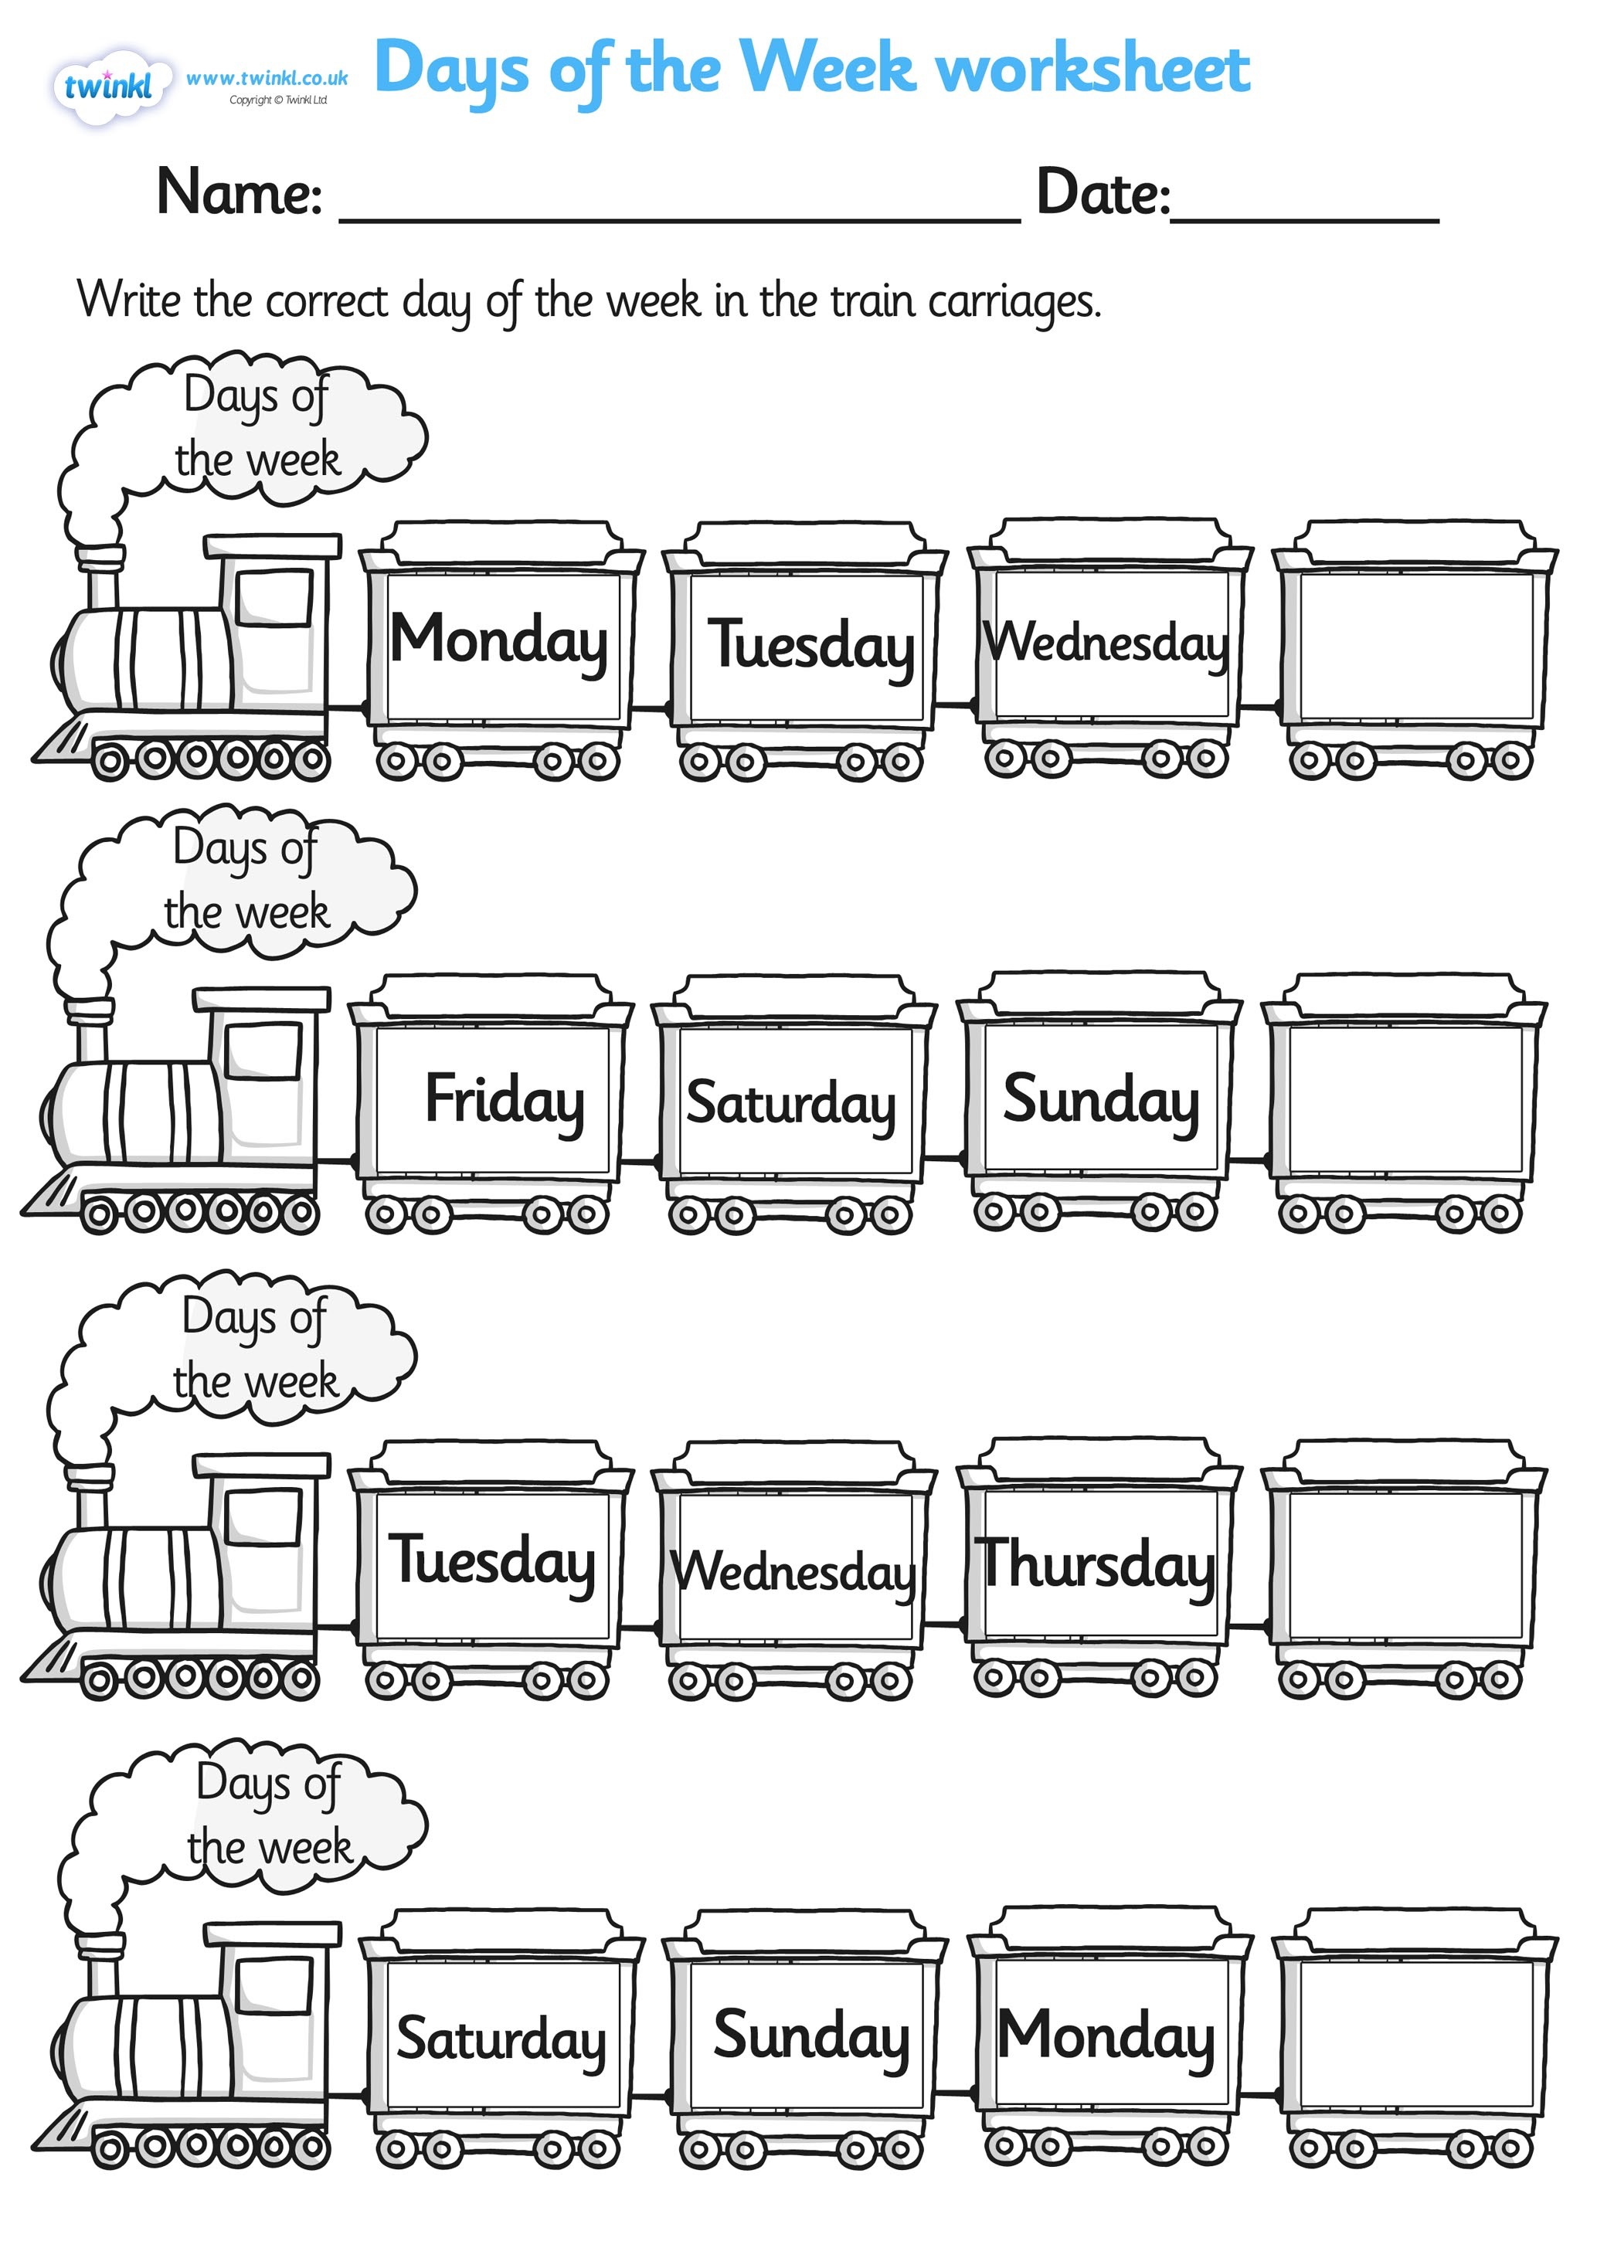

Thaw Space:ssrsb:Desktop:days-of-the-week-worksheet-2.pdf

Thaw Space:ssrsb:Downloads:days-of-the-week-worksheet-3.pdf