I can represent numbers using coins

Lesson Plan Title

I can represent numbers using coins

Lesson Summary

Through a guided lesson students will recognize the value of pennies, nickels, and dimes .
*This took me 3 separate lessons over 3 separate days.

Curriculum Outcomes

N05- Students will be expected to compare and order numbers up to 100
N04- Students will be expected to represent and partition numbers to 100

Assessment Of Learning or Assessment For Learning

Observation, Conversation, Product

Observations
- Do students understand the value of a penny? A nickel? A dime?
- Can students use a penny to represent a given number? Can students use a nickel to represent a given number? Can students use a dime to represent a given number?

Communication/Vocabulary

- Coins
- Penny
- Nickel
- Dime
- Quarter

Technology

- I can represent numbers using coins Key Note Presentation

http://jkeithgrade2mathns.weebly.com/math-wall.html

Materials

- Number line (created in lesson 1)
- Cut outs of pennies, nickels and dimes (see appendix)
- 100 pennies
- 20 nickels
- 10 dimes
- Jar

Mental Mathematics

Review counting forwards by 2’s, 5’s, and 10’s (to 100)

Development

This lesson plan provides students the opportunities to see the sequences and patterns found in the hundreds chart/ number line and extend that knowledge to coins.

Time to Teach

Activate prior knowledge by asking students to count forwards and backwards by 2’s to 20 is what they needed to know in grade one). Show students a real penny/nickel/dime. Ask them if they know what they are looking at, and if they know the names of the coins.
Once students have looked at the coins. Have them think-pair-share their ideas. Usually students should think for at least a minute (maybe more). Once they have thought about the questions above have them go knee to knee to share their answers. Students may mis-name the coins, allow them to converse for a few minutes. Then have them share their answers and ideas. Once they have done that, start with the pennies (I do each coin on a separate day during mental math time). In the jar, add one penny (which represents one cent) up to the number one hundred.

Time to Practice

Then have the students colour in the cut outs of pennies brown OR tape up the real pennies above the number line. To represent 100. Then have students represent a variety of numbers (up to 30 to start) using pennies. Remember to teach children how to draw the cent sign. I usually do this initial task on white boards which allow students to fix their errors and talk to one another about their representations.

Time to Share

Have students share their representations on their white boards. Talk about how students represented coins (some may put circles around others may just right 1 with the cent sign). Remind students who have not used the cent sign, to include it. Then have students watch the key note presentation I can represent numbers using coins. This presentation includes pennies, nickels and dimes.

* See below above ALL numbers to 100 are pennies, below 5’s are nickels and below 10’s are dimes.

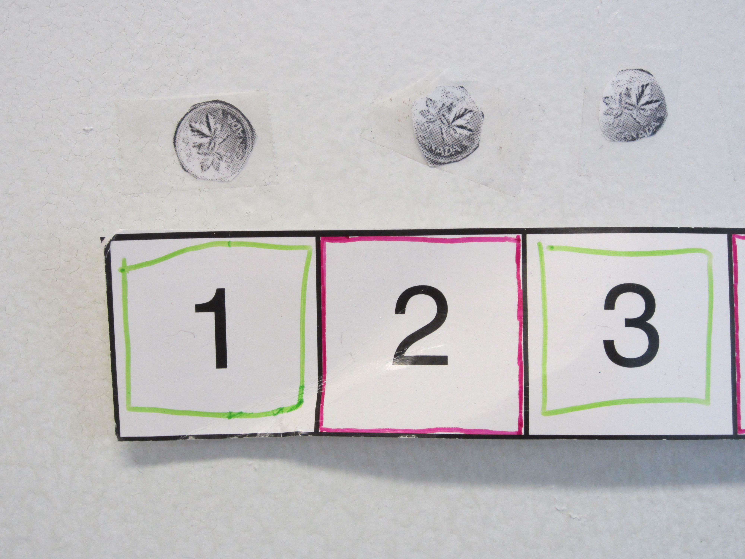

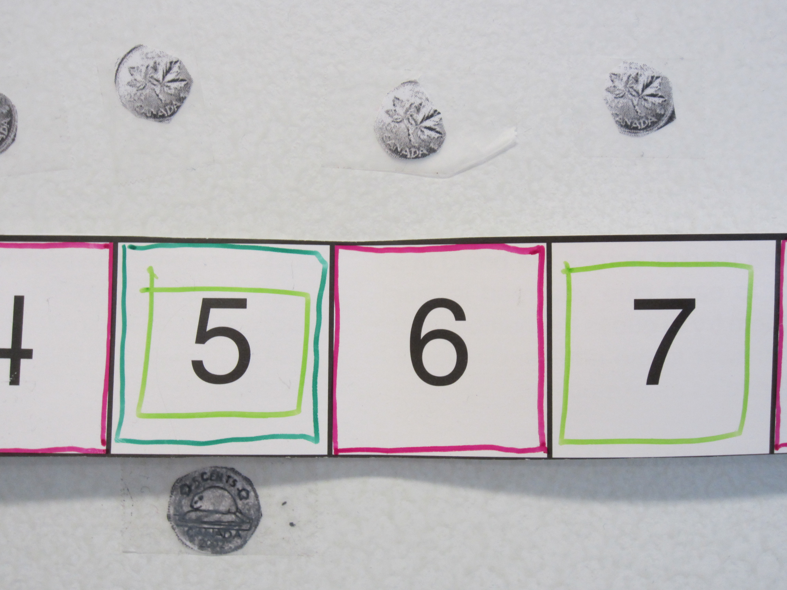
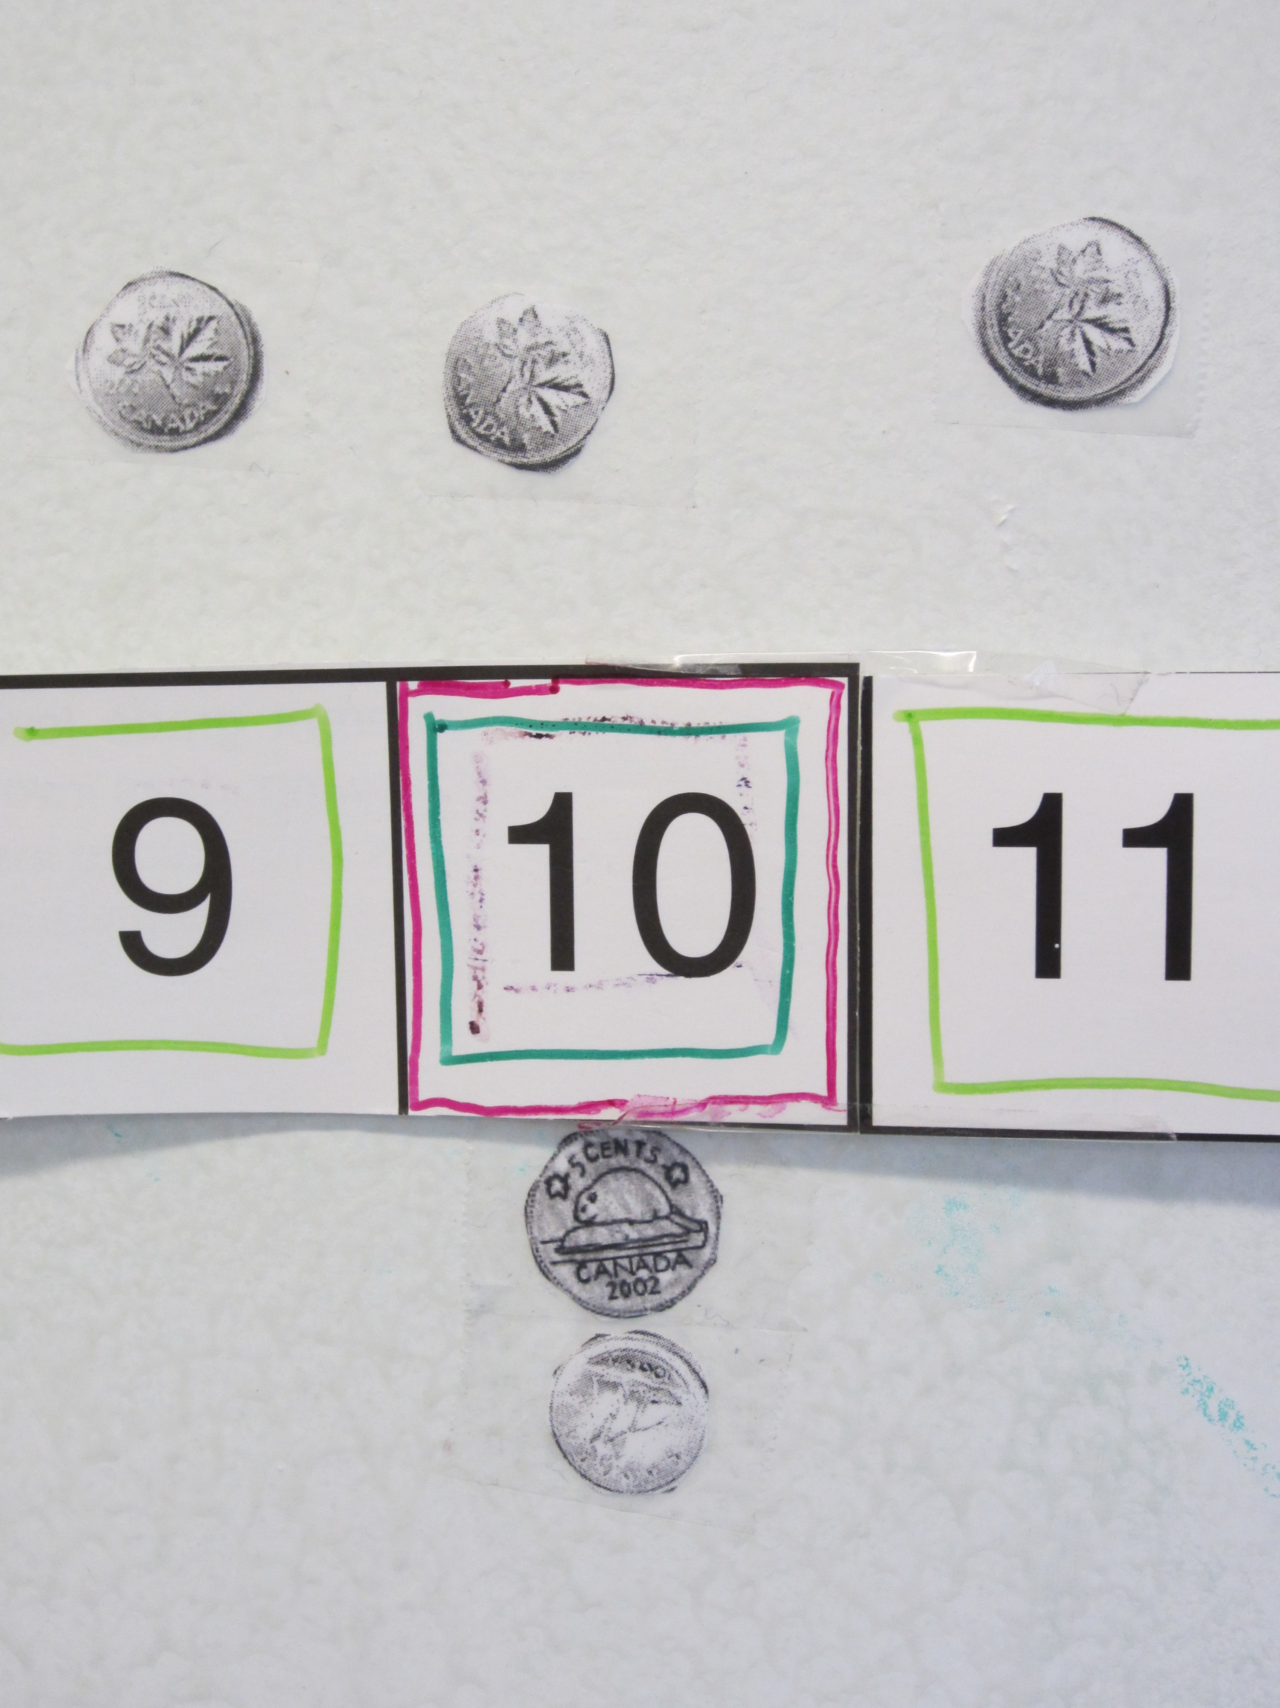

Differentiation

- For those students who do not understand money a guided math group would help them to work with coins- to 20 at first.
- For enrichment students can represent higher numbers using coins, or start to use combinations of coins to represent numbers.

Canadian Currency (coins 1)
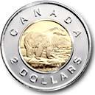
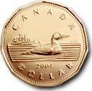
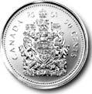
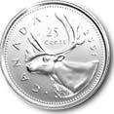
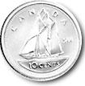
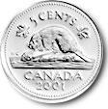
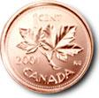
Canadian Currency (coins 2)
Canadian Currency (coins 3)

Coin designs courtesy of the Royal Canadian Mint / Images courtoisie de la Monnaie royale canadienne

