I can skip count by 2’s, 5’s and 10’s

Lesson Plan Title

I can skip count by 2’s, 5’s and 10’s

Lesson Summary

Through a guided lesson students will recognize the patterns in a number line.

Curriculum Outcomes

N05- Students will be expected to compare and order numbers up to 100
N01- Students will be expected to say the number sequence by 2’s, 5’s, and 10’s.

Assessment Of Learning or Assessment For Learning

Observation, Conversation, Product

Observations
- Can students find patterns in the hundred’s chart/number line.
- Can students colour/put a square around the sequences of 2’s, 5’s and 10’s.
- Do students notice any patterns (ie: 5’s are all on numbers that end in 0 and 5)

Communication/Vocabulary

- Hundreds Board
- Number Line

Technology

- None needed for this lesson

Materials

- Hundreds board
- Number line (created in lesson 1)
- Individual Number Lines created by students ( created in lesson 1)
- 3 different coloured pencil crayons per student

Mental Mathematics

Review counting forwards by 2’s, 5’s, and 10’s (to 100)

Development

This lesson plan provides students the opportunities to see the sequences and patterns found in the hundreds chart and a number line.

Time to Teach

Then ask students to try and extend their counting-some may be able to and others may not. Once students have made the attempt to count by 2’s to 100. Using the number line you created and hung on your math all. Show the students how to put a square using a colour (see below the colour I used is pink).

Time to Practice

Once you have gotten to 20 ask each student to choose one of their 3 colours and continue to extend the pattern on their number all the way to 100.

Time to Share

Have the students share what numbers would be extended in the counting by 2’s sequence, and as they tell you put squares around them on your wall. By the end you will have all of the 2’s outlines in the colour of your choice all the way to 100.

* Repeat this lesson for counting by 2’s, 5’s and 10’s. Later in the year I extended to skip counting by the odd numbers and put green around them. Shown below 5’s are blue and 10’s are purple (which is hard to see).

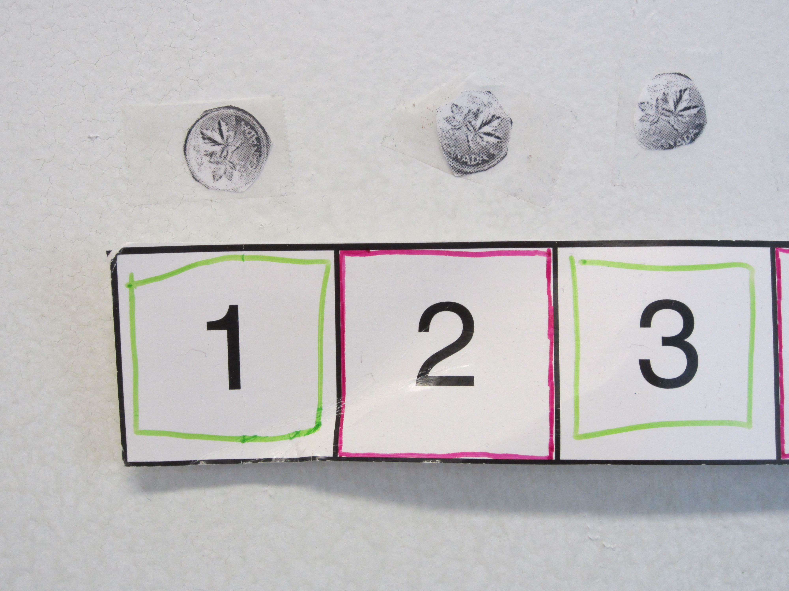

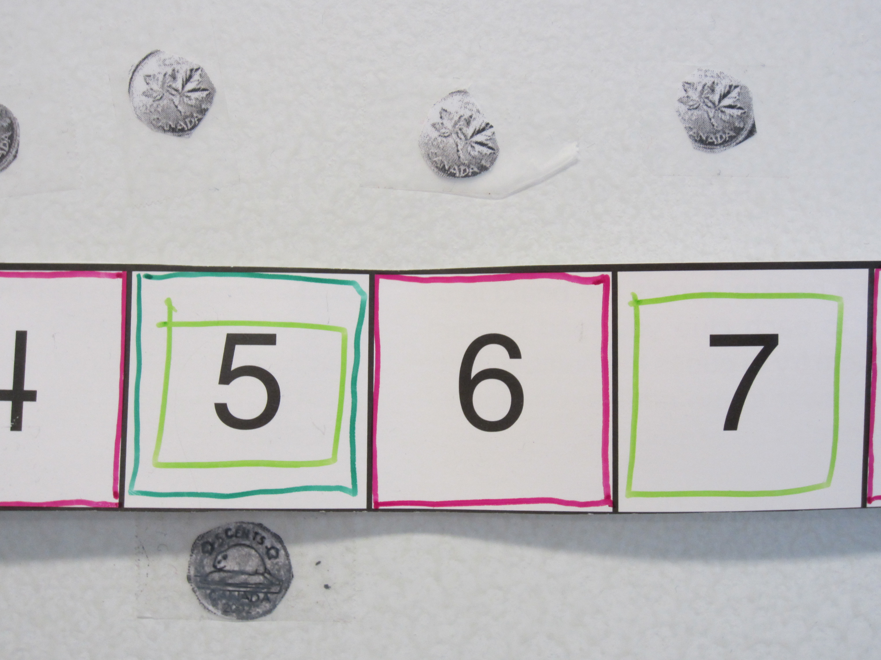
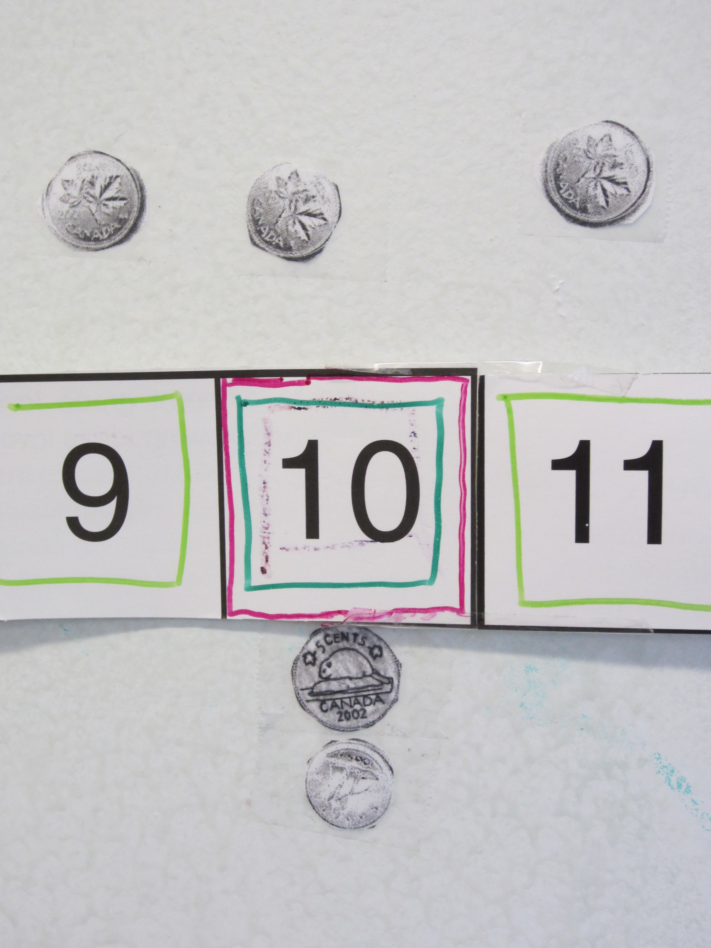

Differentiation

- For those students who struggled to count by 2’s, 5’s and 10’s past 20 create a guided group where you can work together on their number lines to put the colours on- eventually they will hopefully figure out the pattern.

