I can read and use a calendar

Lesson Plan Title

I can read and use a calendar

Lesson Summary

Through a guided lesson, students will learn about the calendar and how we use it. I use this lesson at the beginning of each month again.

* Please note that while this is the initial lesson you will continue to use the calendar everyday for mental math and scheduling activities.

Curriculum Outcomes

M01- students will be expected to demonstrate an understanding of the calendar and the relationships among the days, weeks, months and years.

Assessment Of Learning or Assessment For Learning

Observation, Conversation, Product

Observations
- Can students write the calendar number properly?
- Can students say the date properly?
- Can students determine what tomorrow will be? What yesterday was? What will be three days from now?

Communication/Vocabulary

- Calendar
- Month
- Year
- Date
- Ordinal numbers (ie: first, second etc.)

Technology

- You Tube Video- Days of the Week

https://www.youtube.com/watch?v=yIvQOab00OQ

- You Tube Video- Months of the Year

https://www.youtube.com/watch?v=5enDRrWyXaw
Materials

- Wipe on wipe off calendar
- White board markers
- Days of the week/ Months of the year video

Mental Mathematics

Ask some calendar questions to asses prior knowledge.
If today is Monday what is tomorrow? What was yesterday?
If today is Tuesday how many days has it been since Sunday? How many days until Friday?

*While students answer look for students who seem confused, or unsure and make a note of this.

Development

Play the days of the week song- maybe twice. I don’t use the video I teach them the song and we sing it twice through on a daily basis until students are comfortable answering questions about the days of the week.
I would just play the days of the week song for about a week, and then introduce the months of the year song.
THEN have the helper of the day (I just have one) add the number of the day to the calendar (ie: Monday may be September 1st).

Time to Teach

Talk to the students about the calendar, ask them if they know of any important dates- ie: birthdays are great. That need to be added to the calendar. Once all important dates for the students have been added (be aware they will try to add parents birthdays etc. I always say just people in our classroom need birthdays) then add any important school days ie: trips, days off etc. This gives the students a chance to interact with the calendar. As the year goes on I allow the students to draw the important information on rather then me.

Time to Share

Ask students to go knee to knee and share one important date from the calendar and what day of the week it lands on. They may not know the date as they add a date each day (see above). When students are done discussing the important date that they are aware of have them share what they know about the date. For example the date I picked is on a Monday, it is Billy Bob’s Birthday, and it is on September 13th (some students will figure out the date).

Time to Practice

Have students fill out the blank calendar page and put it in their on mental math books. They can then add the important dates, and the day along with the helper of the day. They will use these calendars on a daily basis to help them understand the calendar better (sheet below).

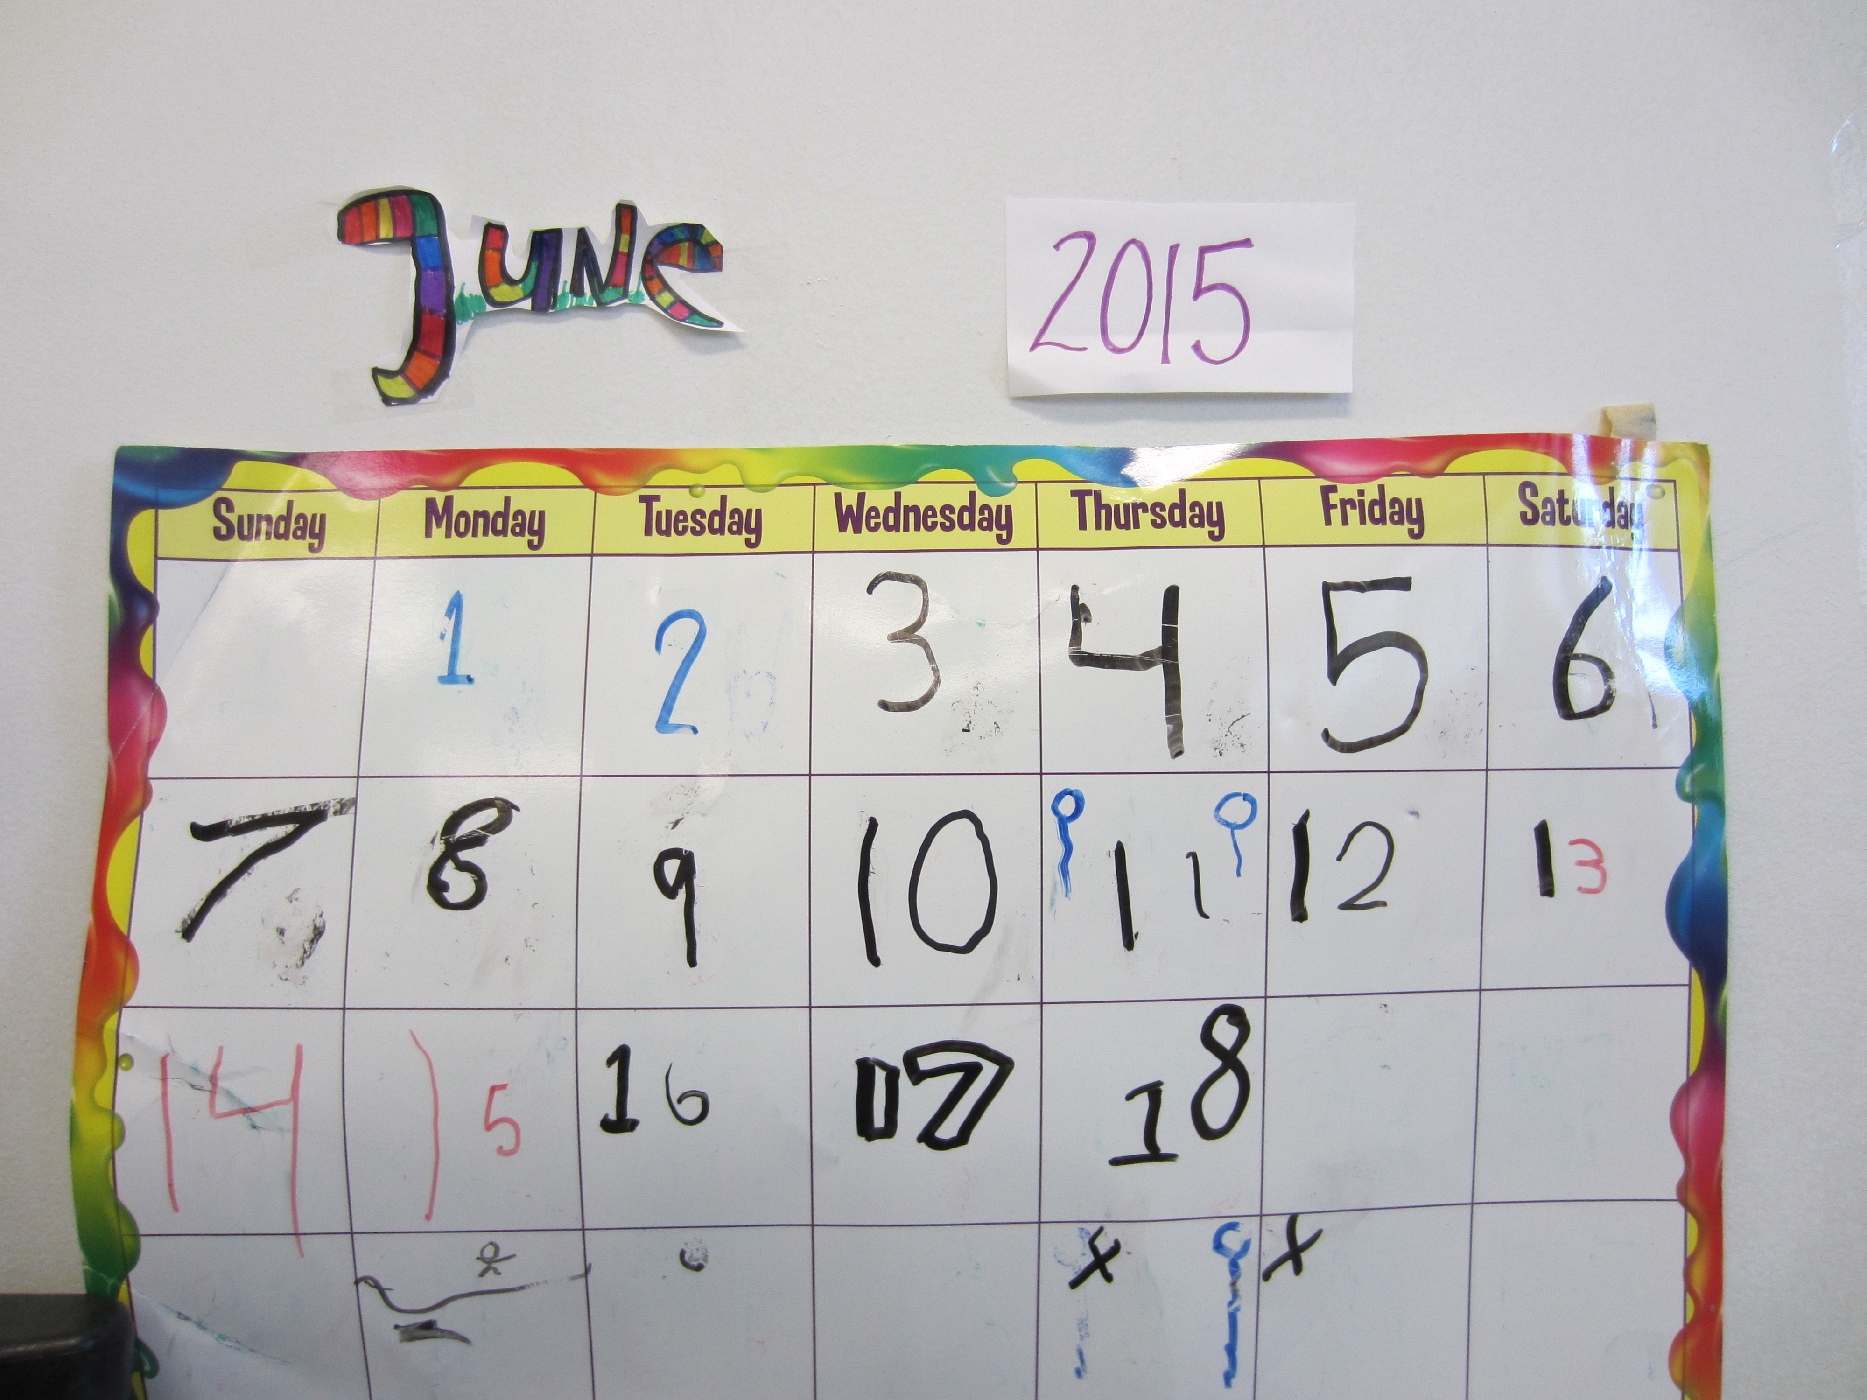

Differentiation

- Some students may need their Calendar books right away to help them solve calendar problems
- More advanced students will need harder questions. How many days between Billy Bob’s birthday and the day that we have no school.

Month: __________________________

Sunday | Monday | Tuesday | Wednesday | Thursday | Friday | Saturday

