There are several reasons why these are called Dash expected behaviours- and no it has nothing to do with an acronym.

One day I asked my students to sit on their bottoms, and one child did it very quickly I praised him as he rarely does anything quickly and is a child who had a challenge following expected behaviours. So I said “Wow J you did that so fast you were like SuperMan” and another child raised his hand and said “Well actually Miss. Keith he did it like Dash from the Incredibles” I agreed and we moved on as a class.

However that night at home I created the poster (below) the students loved Dash expected behaviours because we created it together and they from then on would “compete” to see who could be the super hero that day- it had a lot of leverage in my classroom and motivated them to follow the expected behaviours of the classroom!

Perhaps you might want to have a conversation with the class about what they might want their expected behvaiours to be called, as it might not have as much leverage with another class!

The Expected Behaviours listed below is actually a little poem and is said in almost a chant kind of way. My students though would review the behaviours before entering the hallways and if I said “Dash Expected Behaviours” they would immediately have their hands by their sides, their eyes looking ahead, and one finger on their lip to say they were being quiet. It was very effective for me.

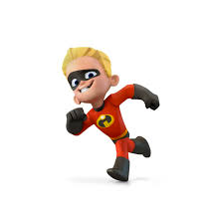
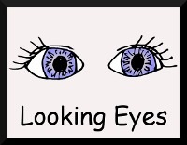
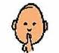
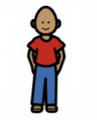
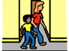
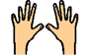
DASH
Expected Behaviour
(Line Up/Hallway)
My hands are hanging by my side
I’m standing straight and tall
My eyes are looking right ahead
I’m ready for the hall
Hip and lip

