I can recognize the pattern to the days of the week

Lesson Plan Title

I can recognize the pattern to the days of the week.

Lesson Summary

Through a guided lesson students will recognize that there is a pattern to the days of the week.

Background

Students were not exposed to the calendar in grade primary or one this is their first time being taught about the patterns in the calendar it may take some time for students to recognize all of the days of the week.

Curriculum Outcomes

M01- students will be expected to demonstrate an understanding of the calendar and the relationships among the days, weeks, months and years.

Assessment Of Learning or Assessment For Learning

Observation, Conversation, Product

Observations
- Can students say the date properly?
- Can students determine what tomorrow will be? What yesterday was? What will be three days from now?

Product
- Can students write the days of the week in order
- Can students put the days of the week in order when they are mixed up?
- Can students recognize there is a pattern to the days of the week?

Communication/Vocabulary

- Calendar
- Month
- Year
- Date
- Days of the week- Monday, Tuesday, Wednesday, Thursday, Friday, Saturday, Sunday

Technology

- You Tube Video- Days of the Week

https://www.youtube.com/watch?v=yIvQOab00OQ
Materials

- Wipe on wipe off calendar
- White board markers
Mixed up Days of the week

Mental Mathematics

Ask some calendar questions to asses prior knowledge.
If today is Monday what is tomorrow? What was yesterday?
If today is Tuesday how many days has it been since Sunday? How many days until Friday?
Review doubles facts: ie: 7 plus 7, as well as facts that add to 7. 6+1= 7+0 (etc.)

*While students answer look for students who seem confused, or unsure and make a note of this.

Development

Play the days of the week song- maybe twice. I don’t use the video I teach them the song and we sing it twice through on a daily basis until students are comfortable answering questions about the days of the week.

Time to Teach

Talk to the students about the days of the week. Ask students to say the days of the week in order with a think-pair-share partner. Remind students it is okay if they get mixed up, just take a deep breath and try again.

Time to Practice

Have students complete the mixed up days of the week sheet below, to help them see the pattern in the calendar.

Time to Share

Have students share and compare their work in whole group lesson. Take notes on the anecdotal evidence sheet of how students used the worksheets. There are three worksheets so the lessons may take more then one day to complete and share.

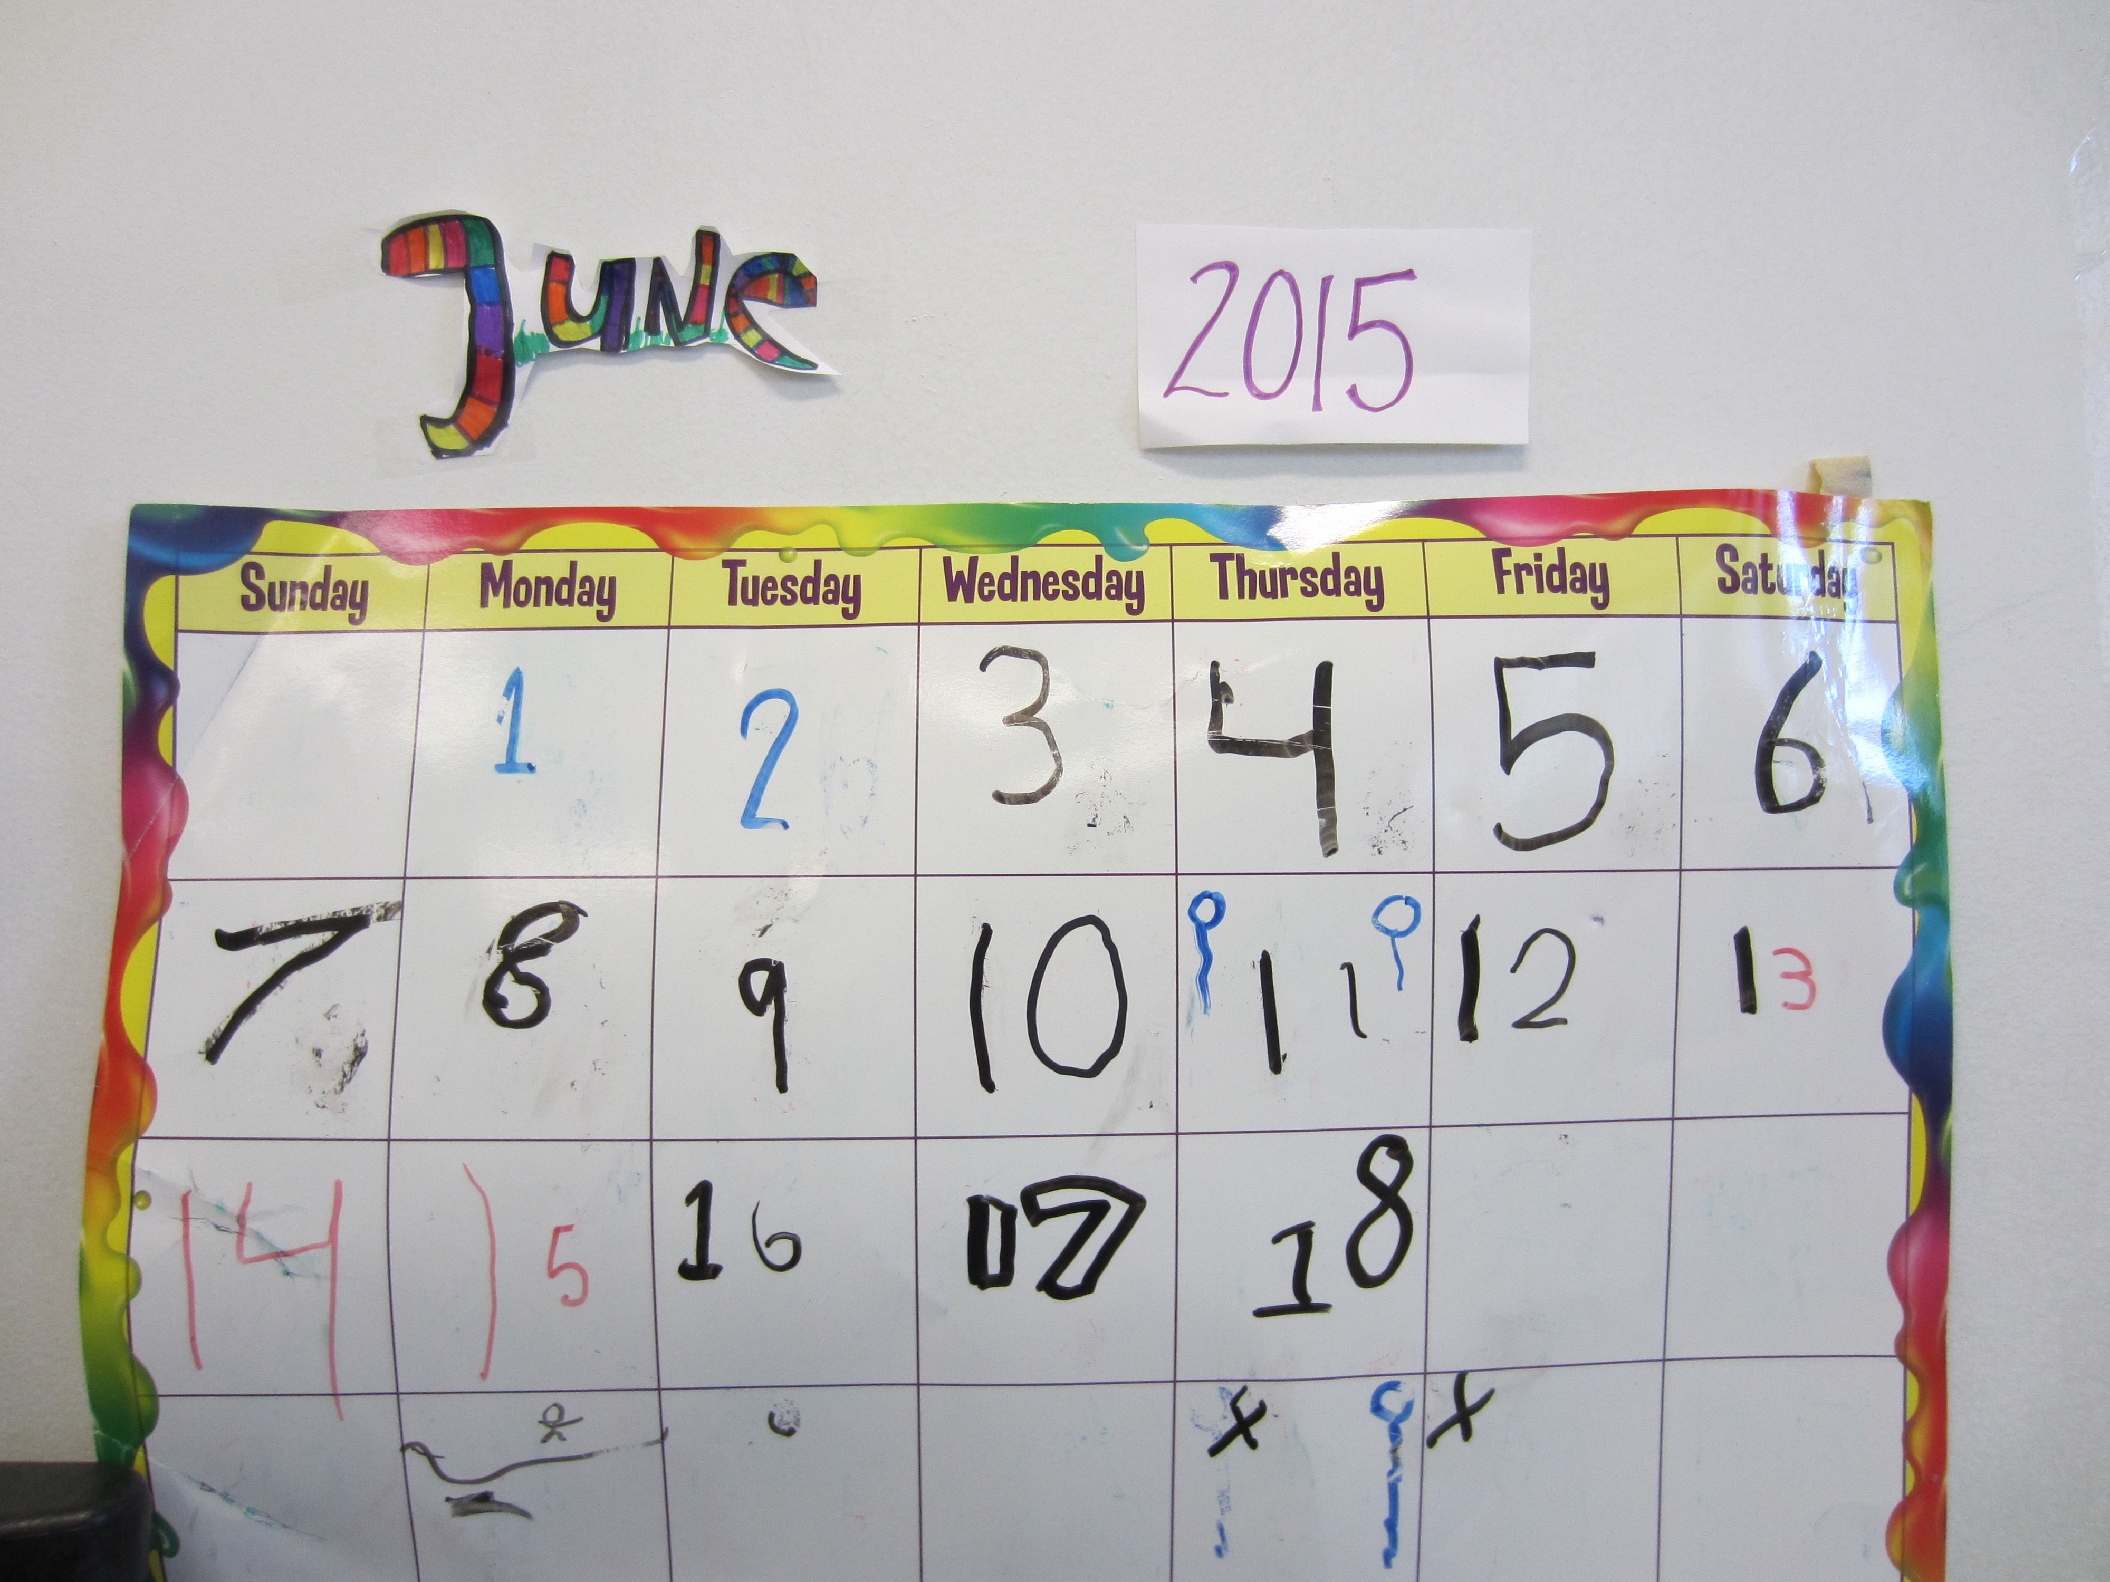

Differentiation

- Some students may need their Calendar books right away to help them solve calendar problems
- For enrichment have students make predictions about what the calendar will look like next month

Mixed up Days of the Week
I can put the days of the week in order
Name: ______________________________________
The days of the week are all mixed up cut them out and glue them onto a new piece of paper with your NAME on it to help the days of the week get back in order!

Friday
Tuesday
Monday
Thursday
Sunday
Wednesday
Saturday

