I can represent a given set using 10s and 1s

Lesson Plan Title

I can represent a given set using 10s and 1s.

Lesson Summary

Students are expected to be able to represent a given set of numbers using 10s and 1s.

*Please note I would do this activity more then once, replacing the sheet with white boards, math journals, etc. Eventually I would no longer give them the t-chart to record their evidence instead I would provide them with a blank sheet to see what they could produce on their own.

Curriculum Outcomes

N04-Students will be expected to represent and partition numbers to 100
Performance Indicator N04.01-Represent a given number using concrete materials, such as base-ten materials
N07-Students will be expected to illustrate, concretely and pictorially, the meaning of place value for numbers to 100
Assessment Of Learning or Assessment For Learning

Observation, Conversation, Product

Observations
- Can students represent a given set using tens and ones

Product
- Can students record how they represented their set using tens and ones?

Communication/Vocabulary

- Ones
- Tens
- Place Value
- Manipulatives
- T-chart

Technology

- I can represent numbers using tens and ones Key Note Presentation

http://jkeithgrade2mathns.weebly.com/place-value.html

- Virtual Manipulatives for the computer

http://www.glencoe.com/sites/common_assets/mathematics/ebook_assets/vmf/VMF-Interface.html

Materials

- Base ten blocks (magnetic and paper if you have a magnetic bulletin board)
- T-chart
- White Board, Chart Paper, Smartboard software
- Unifix Cubes in labelled ziplock bags 1-20 (1 for each student)- you should record how many unifix cubes are in each bag (use the chart below)
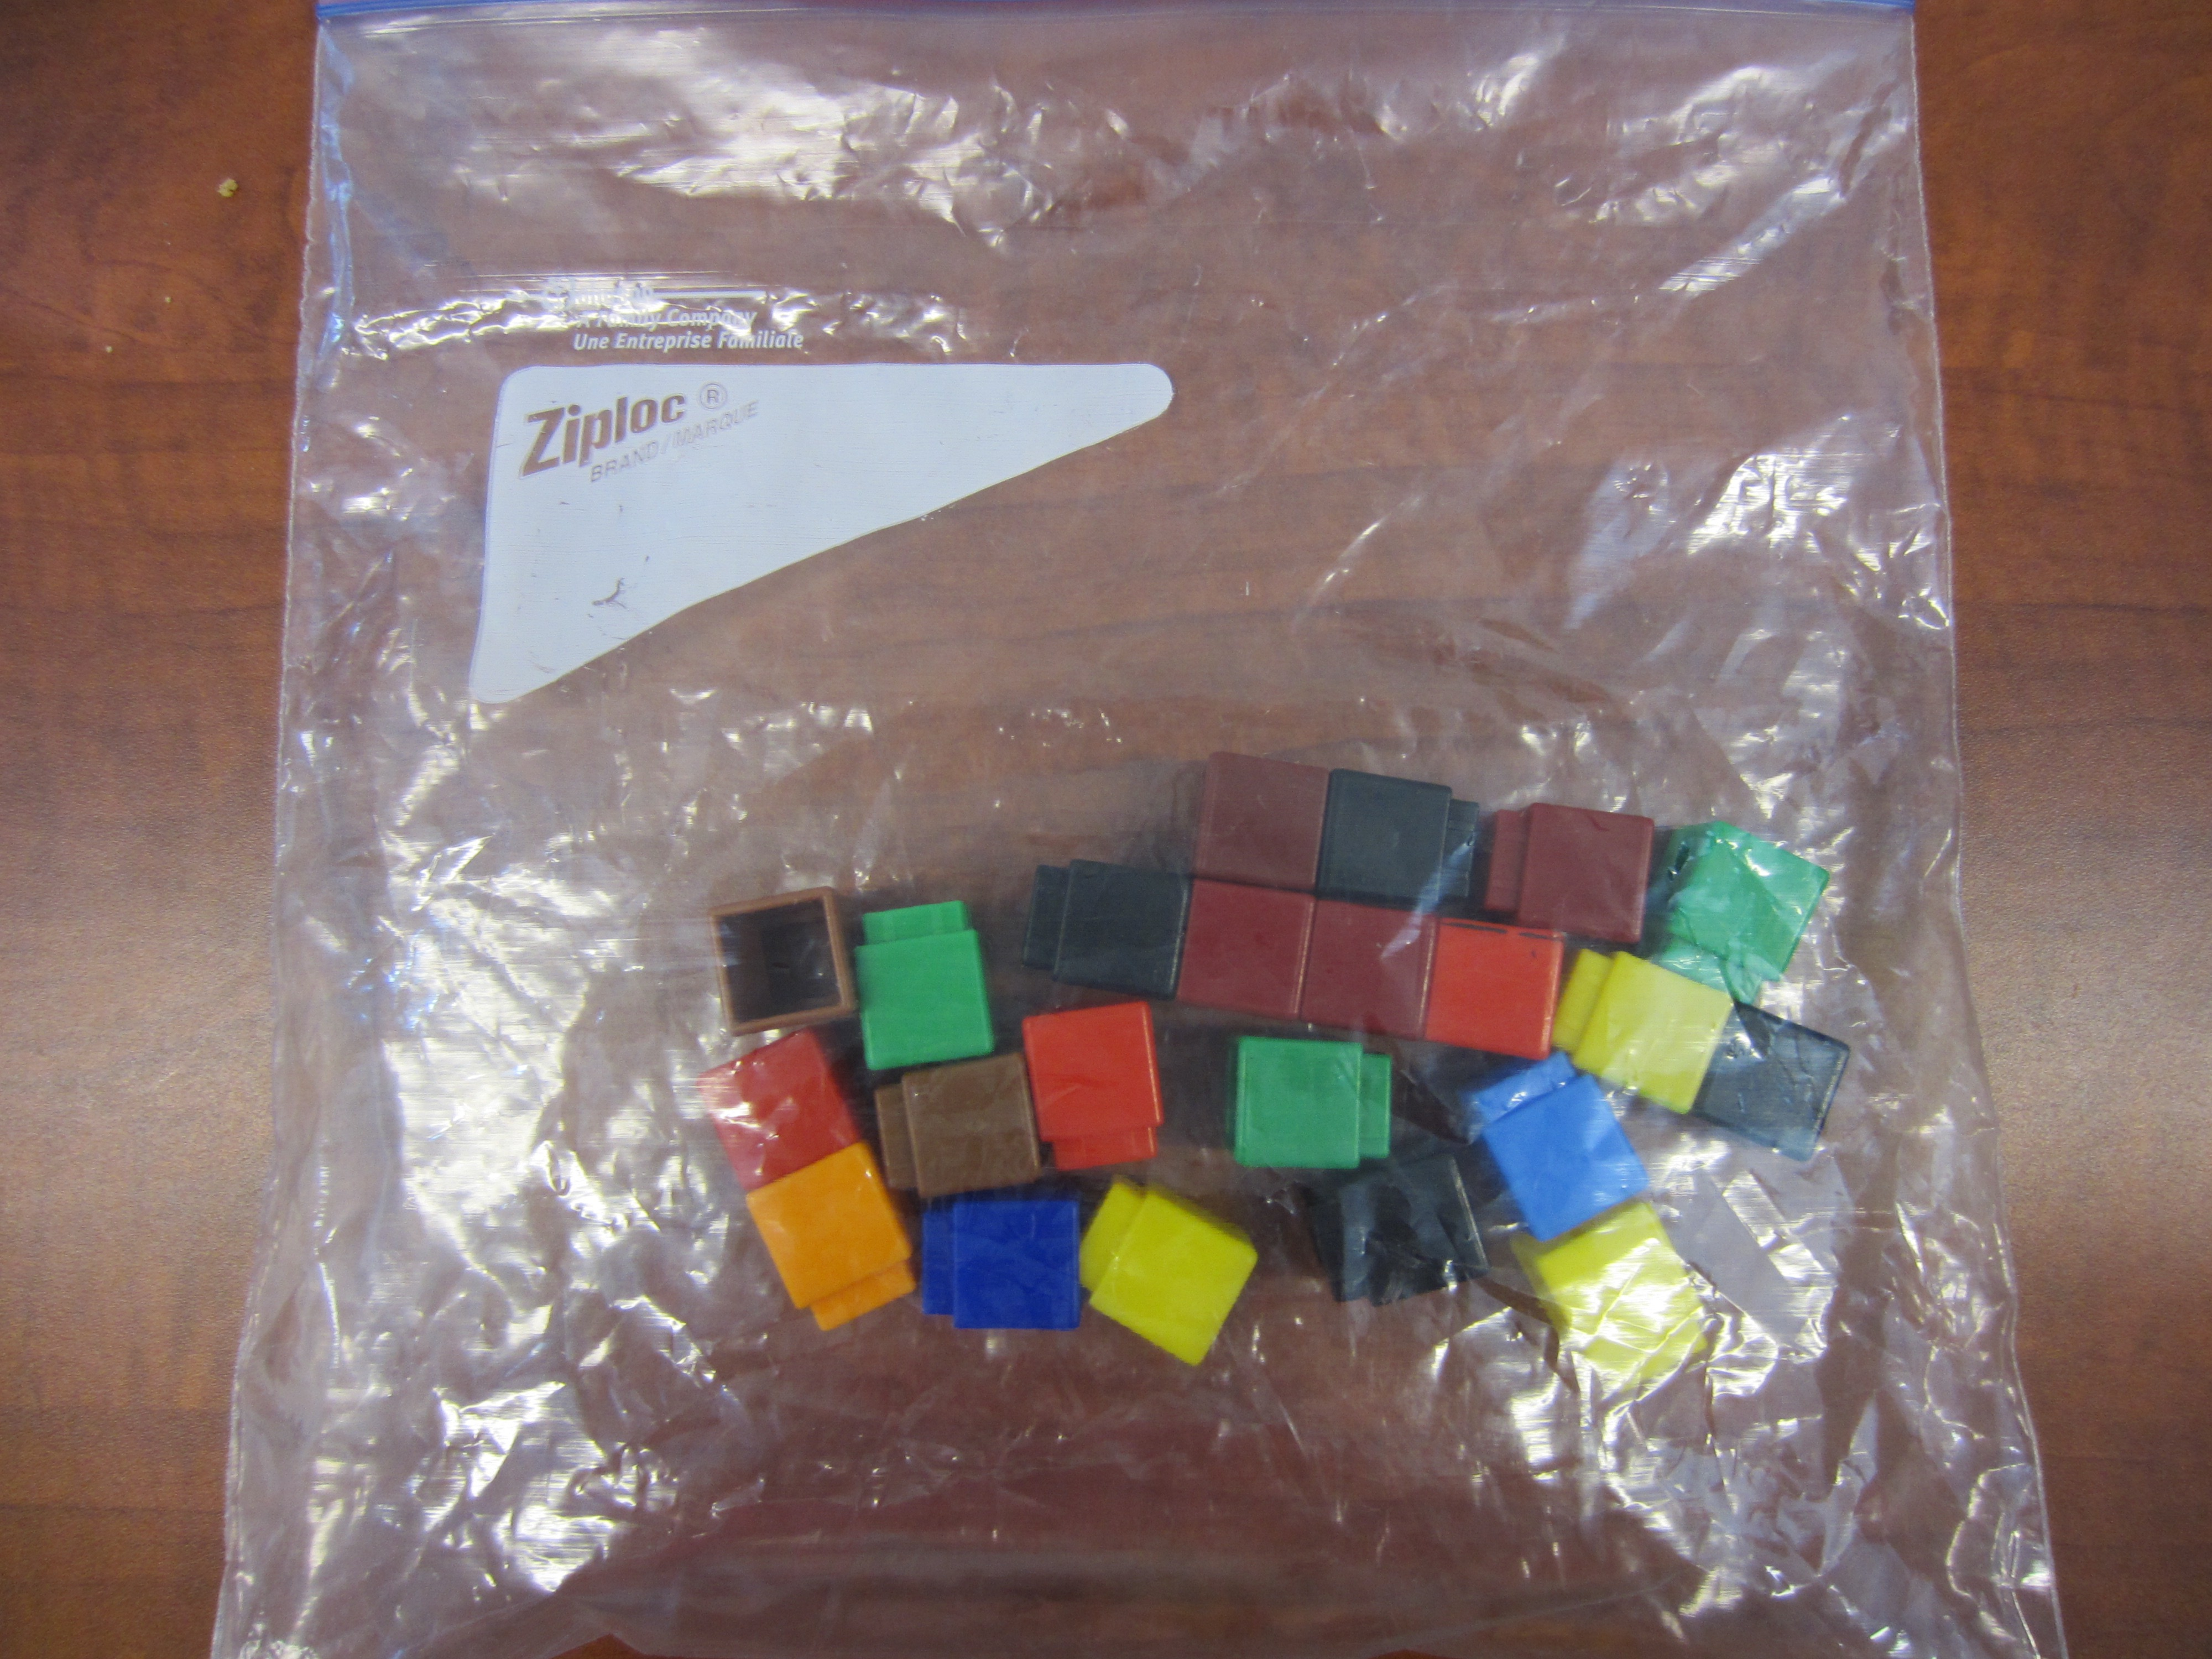

*For Math Manipulative Storage Please See:
http://jkeithgrade2mathns.weebly.com/math-manipulatives.html
Mental Mathematics

Review counting forwards by 10s and 1s

Review counting backwards by 10s and 1s- I do beep beep back up, so we start at 100 and we beep to 90 where the students say stop and then say the number 90.

Development

This lesson provides students with the opportunity to explore numbers more deeply and form connections with numbers.

Time to Teach

Activate knowledge by asking students to start at 50 and count forward to 90 by 10’s. Then ask them to start at 30 and count forward by 10’s to 100. Have them start at 70 and count backwards to 40 by 10’s. Have them start at 52 and count forward by 1s to 78. Have them start at 33 and count backwards by 1s to 17. Do this until you feel the majority of the class is feeling comfortable and confident.

Once this is over, use the math wall to review tens and ones, and what they represent.

Then go through the expected behaviours with math manipulatives. Manipulatives are for learning not for playing. Remind students that if they are playing they will be asked to go back to their seat and watch the class for expected behaviours. They will then be expected to share an expected behaviour they noticed with the class during share time and to complete their work at recess (most students only have to do this once).

Time to Practice

Hand out the recording sheet and manipulatives (I usually set a given amount of manipulatives per table). Have students choose a quiet spot to work with their manipulatives. Set a timer for 10 minutes, remind students they are expected to represent their unifix cubes using 10s and 1s and should start by recording what their number is before breaking it down into 10s and 1s.

Tech Integration

Some students may wish to work on the computer to use manipulatives to represent their numbers
http://www.glencoe.com/sites/common_assets/mathematics/ebook_assets/vmf/VMF-Interface.html

is a great website to use. On the left hand side it asks which grade level I always select 1 or 2 depending on the student using the program. Then they are able to use the mouse to represent numbers. We have a class set of netbooks which I sometimes bring into the classroom to use.

*Please note there are also a lot of App’s for the iPad that work as well, however many require a pay for membership or pay to download. I have yet to find any that are free.

Time to Share

Students should return to the main group to share at the end. Explain to students that knowing the value of each digit is important because it will help when solving addition and subtraction problems as well as when they are working at partitioning numbers. Explain that tens and ones is a way of partitioning because we are breaking the number into two or more parts.

Differentiation

- Struggling students will require a guided math group to solve these types of problems
- For enrichment ask students to take an extra bag, and add the two bags together using tens and ones as their adding problem. (ie: 22 plus 44 would look like 20+40+2+4=66

Name: _______________________________
Tens | Ones

Unifix Cubes- Ziplock Bag Recording Sheet
Bag | Number of Cubes
1
2
3
4
5
6
7
8
9
10
11
12
13
14
15
16
17
18
19
20
21
22
23
24
25
26
27
28
29

