I can represent numbers using ones

Lesson Plan Title

I can represent numbers using ones

Lesson Summary

Through a guided lesson students will be introduced to the concept of ones. They will be asked to represent numbers from 0-9 in a variety of ways to ensure they are comfortable with numbers 0-9. At the end of the lesson students will be asked to represent higher numbers using ones- Again this is an introductory lesson.

Curriculum Outcomes

N04-Students will be expected to represent and partition numbers to 100
Performance Indicator N04.01-Represent a given number using concrete materials, such as base-ten materials
N07-Students will be expected to illustrate, concretely and pictorially, the meaning of place value for numbers to 100
Assessment Of Learning or Assessment For Learning

Observation, Conversation, Product

Observations
- Can students represent a given number from 0-9 (and higher) using a variety of manipulatives?
- Can students use unit cubes to represent numbers?

Product
- Using anecdotal evidence did students represent the number using a manipulative of their choice?

Communication/Vocabulary

- Ones
- Place Value
- Manipulatives

Technology

- I can represent numbers using ones Key Note Presentation

http://jkeithgrade2mathns.weebly.com/math-wall.html

- Virtual Manipulatives for the computer

http://www.glencoe.com/sites/common_assets/mathematics/ebook_assets/vmf/VMF-Interface.html

Materials

- Base ten blocks (magnetic and paper if you have a magnetic bulletin board)
- Counters
- Unifix Cubes
- Pennies

Mental Mathematics

Review counting forwards by 1’s.

Review counting backwards by 1’s- I do beep beep back up, so we start at 100 and we beep to 99 where the students say stop and then say the number 99.

Development

This lesson provides students with the opportunity to explore numbers more deeply and form connections with numbers.

Time to Teach

Activate knowledge by asking students to start at 52 and count forward to 60. Then ask them to start at 85 and count forward by 1’s to 100. Have them start at 56 and count backwards to 40. Do this until you feel the majority of the class is feeling comfortable and confident.

Time to Practice

Have students return to their desks and pick a number between 0-9 to represent in a variety of ways. Provide students with math manipulatives unifix cubes, cube-a-links, base ten blocks, counters etc. and have them use those materials to create their number. Using the anecdotal record sheet (see below) record what students do to represent their numbers. If successful have them choose a higher number to represent again recording their work.

Tech Integration

Some students may wish to work on the computer to use manipulatives to represent their numbers
http://www.glencoe.com/sites/common_assets/mathematics/ebook_assets/vmf/VMF-Interface.html

is a great website to use. On the left hand side it asks which grade level I always select 1 or 2 depending on the student using the program. Then they are able to use the mouse to represent numbers. We have a class set of netbooks which I sometimes bring into the classroom to use.

*Please note there are also a lot of App’s for the iPad that work as well, however many require a pay for membership or pay to download. I have yet to find any that are free.

Time to Share

Have students share by going to the museum. In this share activity students come to the meeting spot to “get on the bus” once they are on the bus you drive the bus to the museum. While on the bus the students share expectations at the museum (see expectations poster below). Students then get off the bus and go to the museum to see each other’s work. Sometimes when we go to the museum half of the students are the presenters to share their work, then they switch. It depends on what they are presenting and if there needs to be someone beside the work. For this activity I would say everyone goes to the museum together.

Once students have shared their work, have them return to the meeting spot. At this point share with students that there is a special item that represents ones, it is called a unit cube. Show them the printable version of the unit cube OR show them the magnetic unit cube. Introduce it as like the penny, and place a unit cube above each number on your number line. (I did not do this last year but I would hang them above the pennies on the number line).

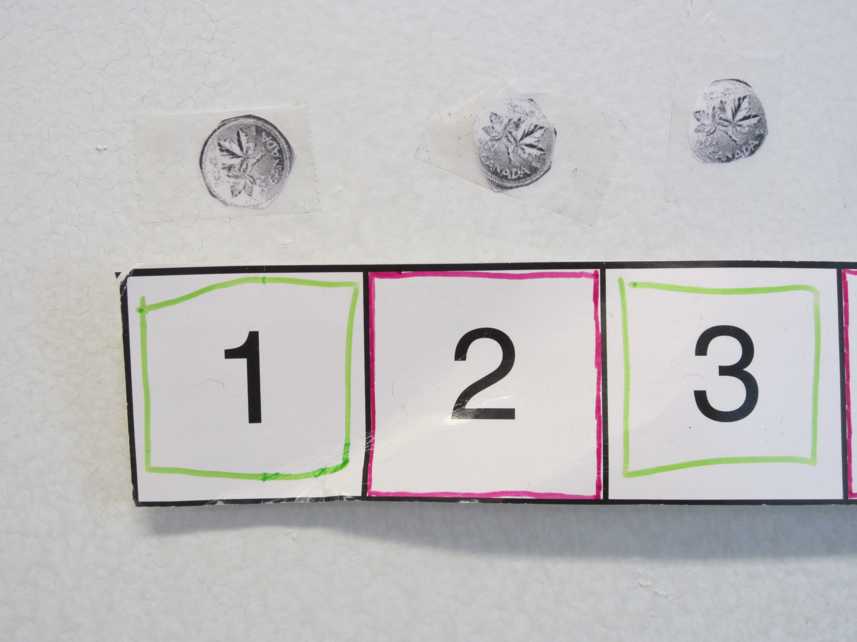

Differentiation

- Some students may need to work at representing higher numbers together. Some may require a guided math group to work on concepts such as numbers 1-9 or higher.
- For enrichment ask students how they might represent 2 digit numbers differently then one digit numbers.

Going to the Museum-Expectations

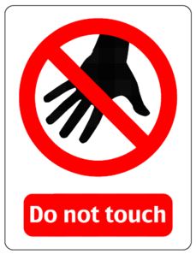 Do not touch other other’s work
Ask questions about the work you
are looking at
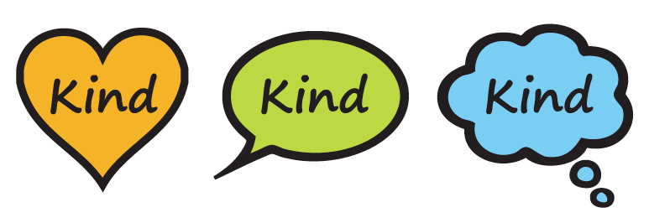 Use Kind words to describe
other’s work

Anecdotal Records
Place a student name in each box, then you are able to record student responses to questions

Base 10 Blocks (all)

