Going to the Museum-Expectations

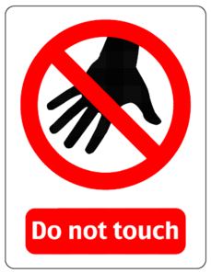 Do not touch other other’s work

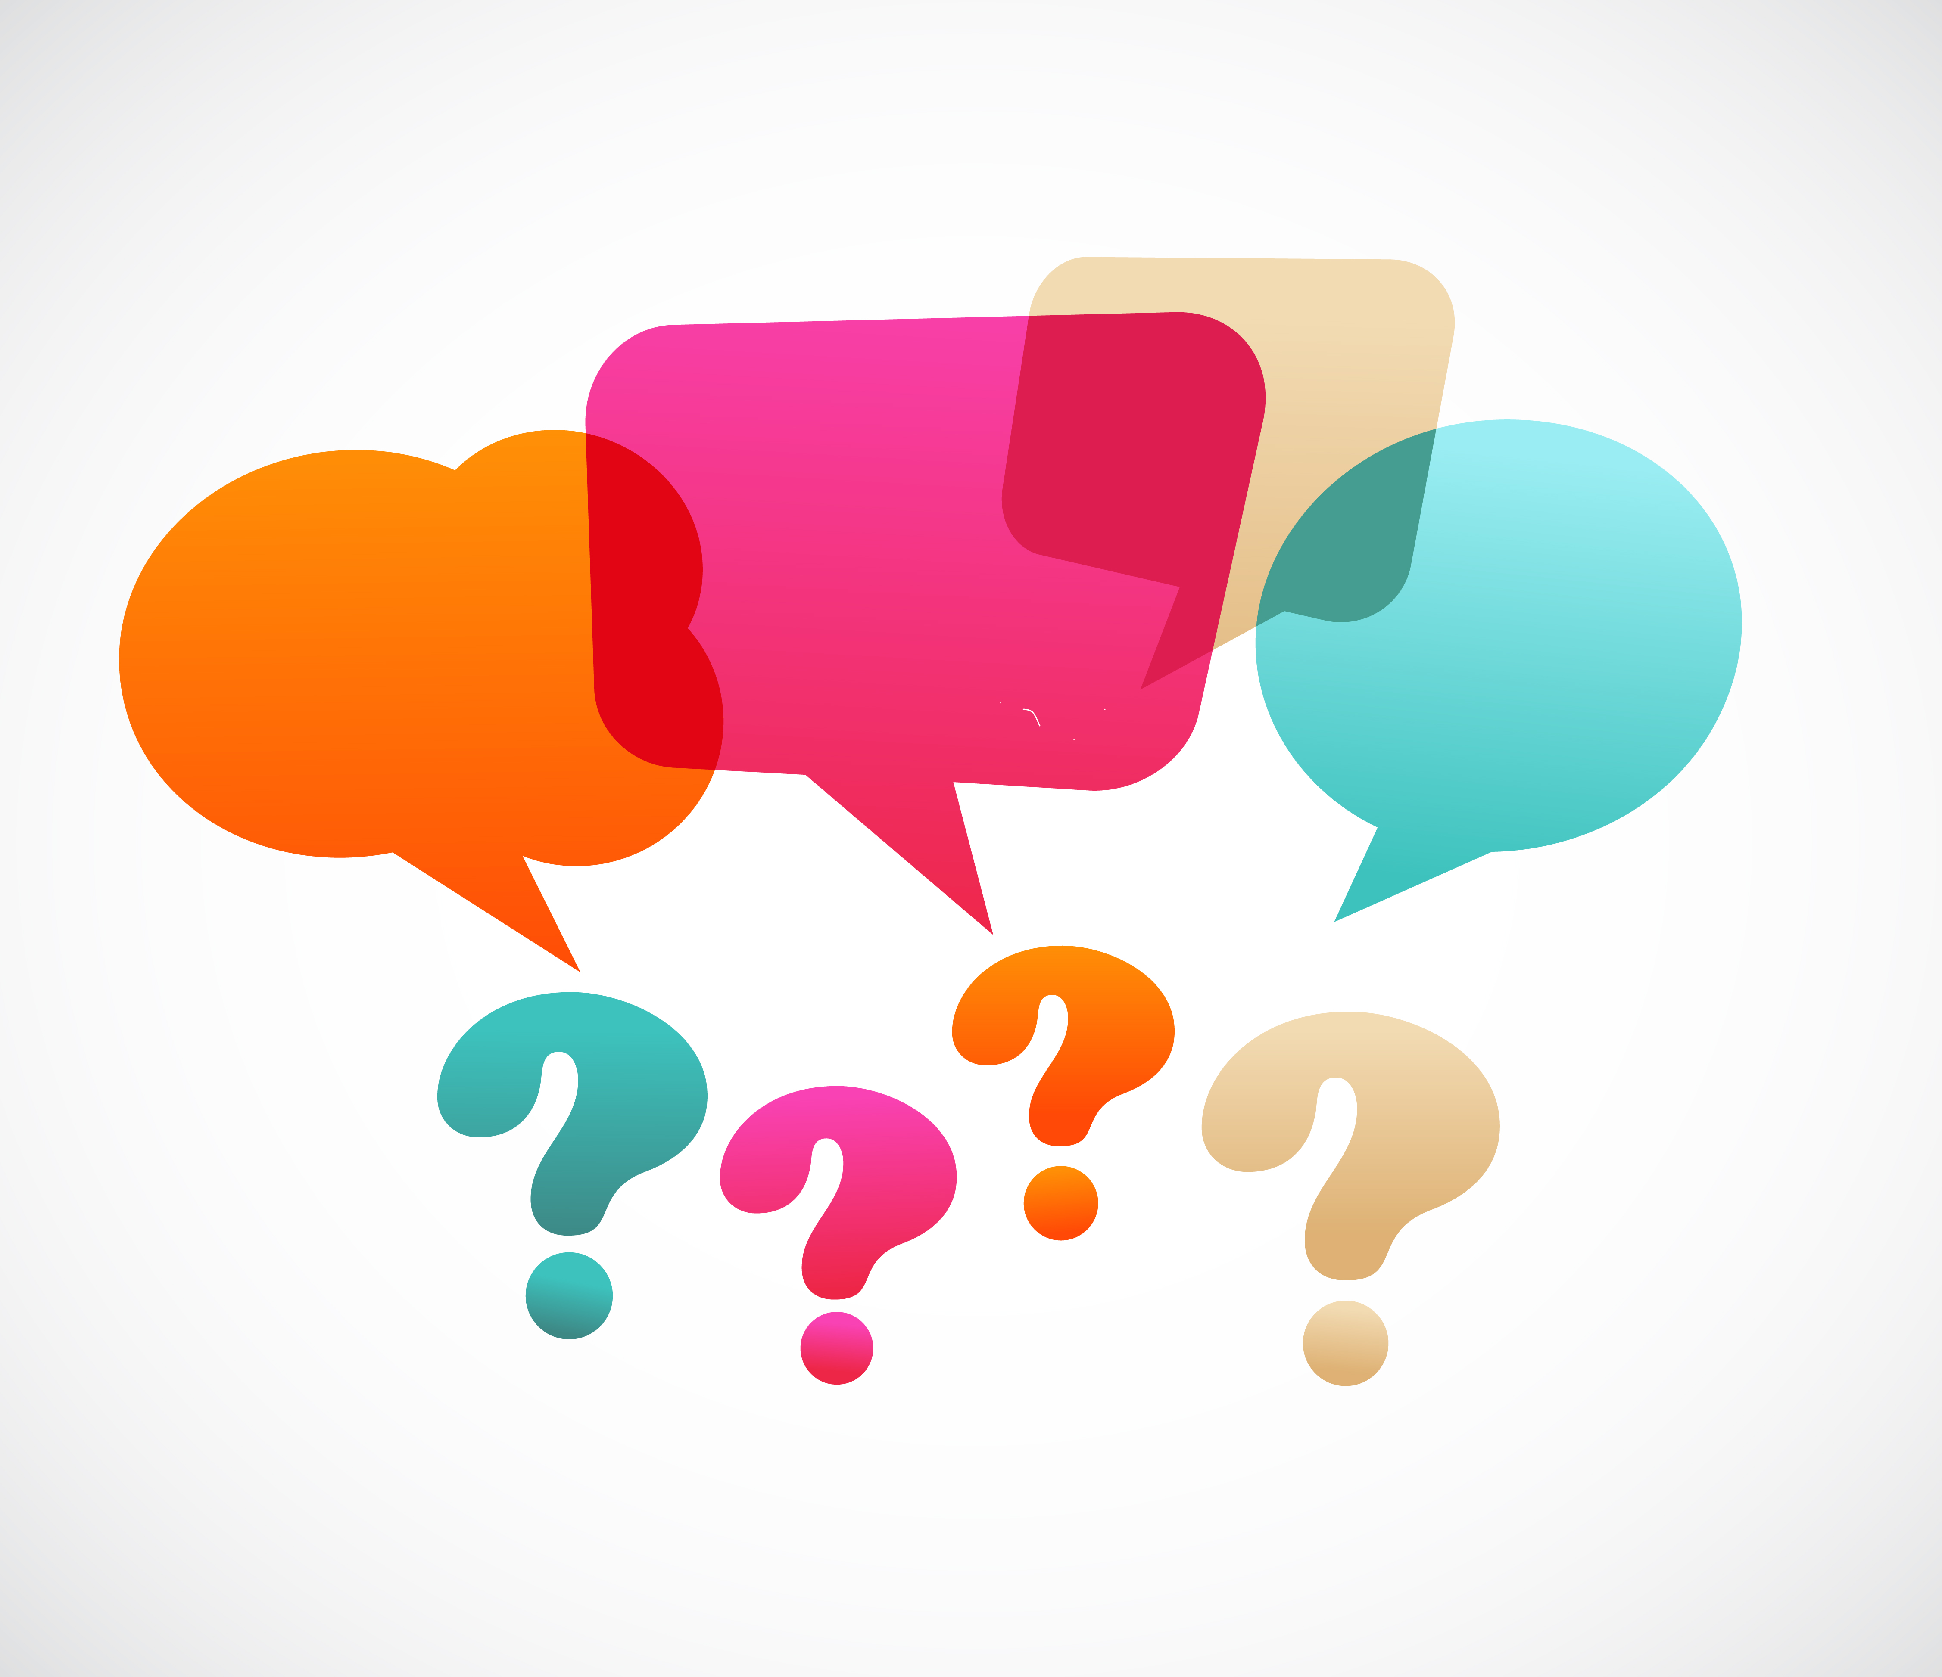 Ask questions about the work you are looking at

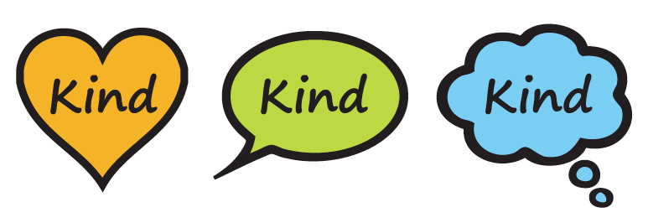 Use Kind words to describe other’s work

