There are several reasons why these are called Dash expected behaviours- and no it has nothing to do with an acronym.

One day I asked my students to sit on their bottoms, and one child did it very quickly I praised him as he rarely does anything quickly and is a child who had a challenge following expected behaviours. So I said “Wow J you did that so fast you were like SuperMan” and another child raised his hand and said “Well actually Miss. Keith he did it like Dash from the Incredibles” I agreed and we moved on as a class.

However that night at home I created the poster (below) the students loved Dash expected behaviours because we created it together and they from then on would “compete” to see who could be the super hero that day- it had a lot of leverage in my classroom and motivated them to follow the expected behaviours of the classroom!

Perhaps you might want to have a conversation with the class about what they might want their expected behvaiours to be called, as it might not have as much leverage with another class!
There
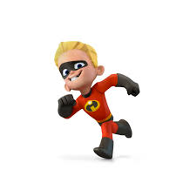
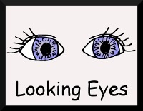
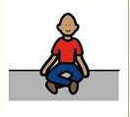
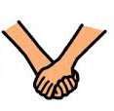
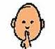
DASH
Expected Behaviour
(Meeting spot)
Look at the speaker or activity
Listen to the speaker
Sit on your bottom
Hands and feet to yourself
Mouth is quiet, raise your hand when you have something to say

