I can represent numbers using coins

Lesson Plan Title

I can represent numbers using coins

Lesson Summary

Students will be expected to use coins to represent numbers

*Please note that you will be able to use this lesson more then once changing the range of numbers students will use.

Background

In grade one students were expected to represent numbers to 20. Students in grade one are not introduced to the concept of coins, this is a grade two concept and begins in Unit 1.

Curriculum Outcomes

N04- Students will be expected to represent and partition numbers to 100
Performance Indicator N04.01- represent a given number using coins (pennies, nickels, dimes and quarters)

Assessment Of Learning or Assessment For Learning

Observation, Conversation, Product

Observations
- Daily checklist- Can students represent a number using coins on their white boards

Conversations
- Can a student answer questions about coins. I have 35 cents I spent ten cents on a pencil, how much money do I now have?
- Can students tell you the value of two coins? I have two nickels and a dime how much money do I have?

Product
- Can students represent a given/chosen number using coins? Can they do so efficiently (ie: 33 cents as 33 pennies is not the most efficient way)
Communication/Vocabulary

- Pennies
- Nickels
- Dimes
- Quarter
- Coins
- Change
- Money
- Cents

Technology

- I can represent numbers using coins- Key Note Presentation

http://jkeithgrade2mathns.weebly.com/partitioning.html

- I-pad/Digital Camera to take pictures of work with plastic coins (if necessary)
Materials

- Number Line with coins taped above (see Lesson 3 Math Wall)
- Paper or Plastic Canadian Coins for students
- Sticky Notes (post it notes)
- Markers
- Anecdotal Record sheet (http://jkeithgrade2mathns.weebly.com/general-assessment.html )
- Math Journals- My math journals are the hilroy scribblers where half the page is for writing and half is for drawing. It looks something like this.

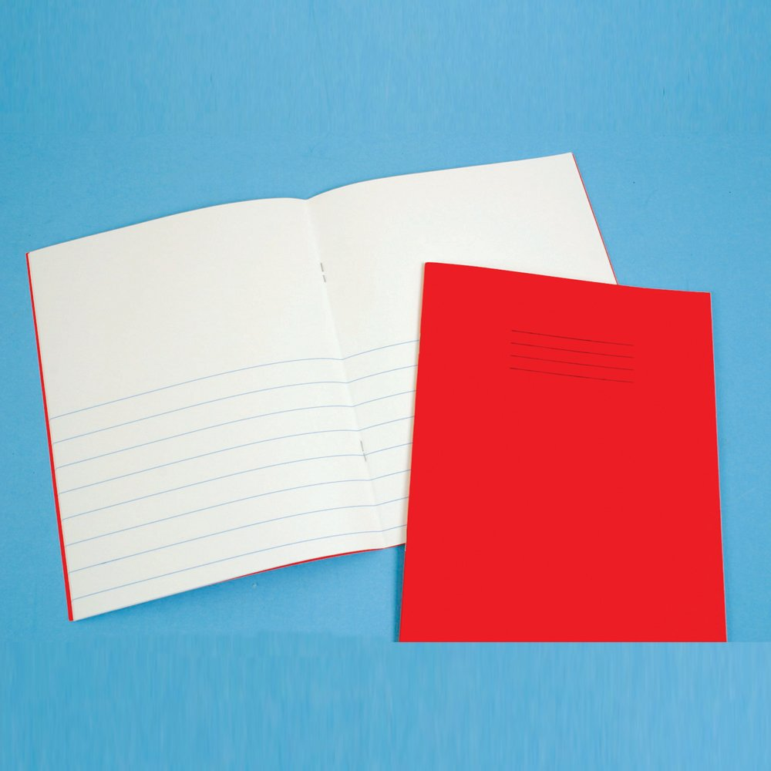

Mental Mathematics

Ask students to solve basic questions involving coins. I have 2 dimes, how much money do I have? I have 5 nickels how much money do I have? I have one quarter and two pennies how much money do I have? (etc.) During this time, you may want to make note of students who do not answer, or who answer with random answers. Ask students to share their strategies of how they solved these problems in their heads.

Development

This lesson is a lesson that you could adapt to different situations. You may choose to replace math journals with white boards until students are comfortable representing numbers using coins.

Time To Teach

Activate prior knowledge by asking students to identify which coin above the number line is a penny, nickel, dime and quarter. Once students have identified all of the coins explain that students will be using coins today to represent a number. Students may need to be taught how to draw each coin (see below)

10 ¢
Time to Practice
5 ¢
1 ¢

Once students are comfortable drawing coins have them choose a number between 20-50 to represent in their math journals using coins. Remind students that they need to use the cent sign or you will not know what they are representing. Hand each student a sticky note so they are able to write the number they have chosen down using a marker (this helps you see which students are still writing numbers wrong or backwards). Have students glue the sticky note into their math journal. Then they can start to represent that number using coins. If you have plastic or paper coins, students could use those instead of drawing out their number. This allows those students who struggle with writing to be able to represent as well. When using the plastic coins students could use an i-pad/digital camera to take a picture of their work and then print it off. Below I have provided a list of steps that students need to do- I post these on my smartboard, but you could use a projector or provide each student with a copy.

Time to Share

Have students bring their math journal to the whole group meeting spot to share their work. Have them share how they represented their number using coins. Some students may have used all pennies, maybe talk with the whole class about how students could share that number more quickly.

Differentiation

- Drawing may be an issue for some students, use plastic coins, or paper coins that they can glue into their journals. If you use the plastic coins they could use an i-pad to take a picture of their work and glue it into their journal
- Some students may find numbers from 20-50 have them choose a lower number to represent using coins.
- Quick finishers should be asked to use coins to represent their number again, this time using different amounts of coins (ie: 33 Cents could be 3 dimes and 3 pennies, or 2 nickels, 2 dimes, and 3 pennies).

I can represent a number using coins- Steps
Step 1: Get your math journal
Step 2: Choose a number between 20-50
Step 3: Write your number on the sticky note using
the marker
Step 4: Represent your number using coins
-You may draw the coins
- You may use the paper money and cut out
the coins
- You may use the plastic money and take a
a picture of your work with the I-pad to
print out
Step 5: If you finish early re-check your work THEN
represent your number using different amounts
coins.

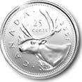
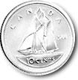
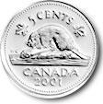
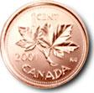
Canadian Currency (coins 2)

