I can create addition number expressions using part part whole

Lesson Plan Title

I can create addition number expressions using part part whole

Lesson Summary

Students will be expected to use the part part whole strategy to create number expressions

*Please note that this is an introductory lesson-by the end of the year students should be able to use the part part whole strategy to solve a wide variety of problems.
Curriculum Outcomes

N04- Students will be expected to represent and partition numbers to 100
Performance Indicator N04.06- Represent a given number using number expressions

Assessment Of Learning or Assessment For Learning

Observation, Conversation, Product

Observations
- Do students use the part part whole strategy during mental math to represent numbers?

Conversations
- Can a student explain why using part part whole helps them solve addition problems?

Product
- Can students use the part part whole strategy using part part whole racers to create addition problems.
Communication/Vocabulary

- Part part whole
- Partition
- Addition, add, plus, more then
- Math Journal
- Number Expression (formally Number Sentence)

Technology

- I can create number expressions using part part whole Key Note Presentation
http://jkeithgrade2mathns.weebly.com/partitioning.html
- iPads (show me APP)

Materials

- Part Part Whole recording sheet (see below)
- Smart board (smart interactive technology)
- Example of a part part whole- One of my students this year recognized the wall was an example of part part whole. I made digit cards and would attach them onto the wall when using examples of part part whole

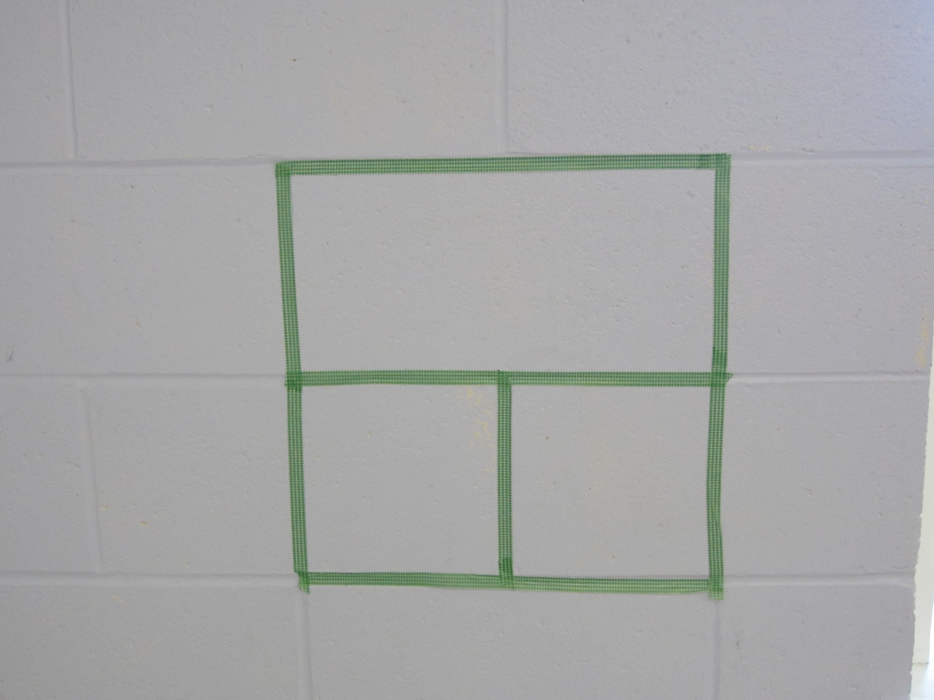

- Part Part Whole Racers- Three paper plates 1 with Whole written on it 2 with Part written on them attached with two strips of Bristol board to the whole plate.
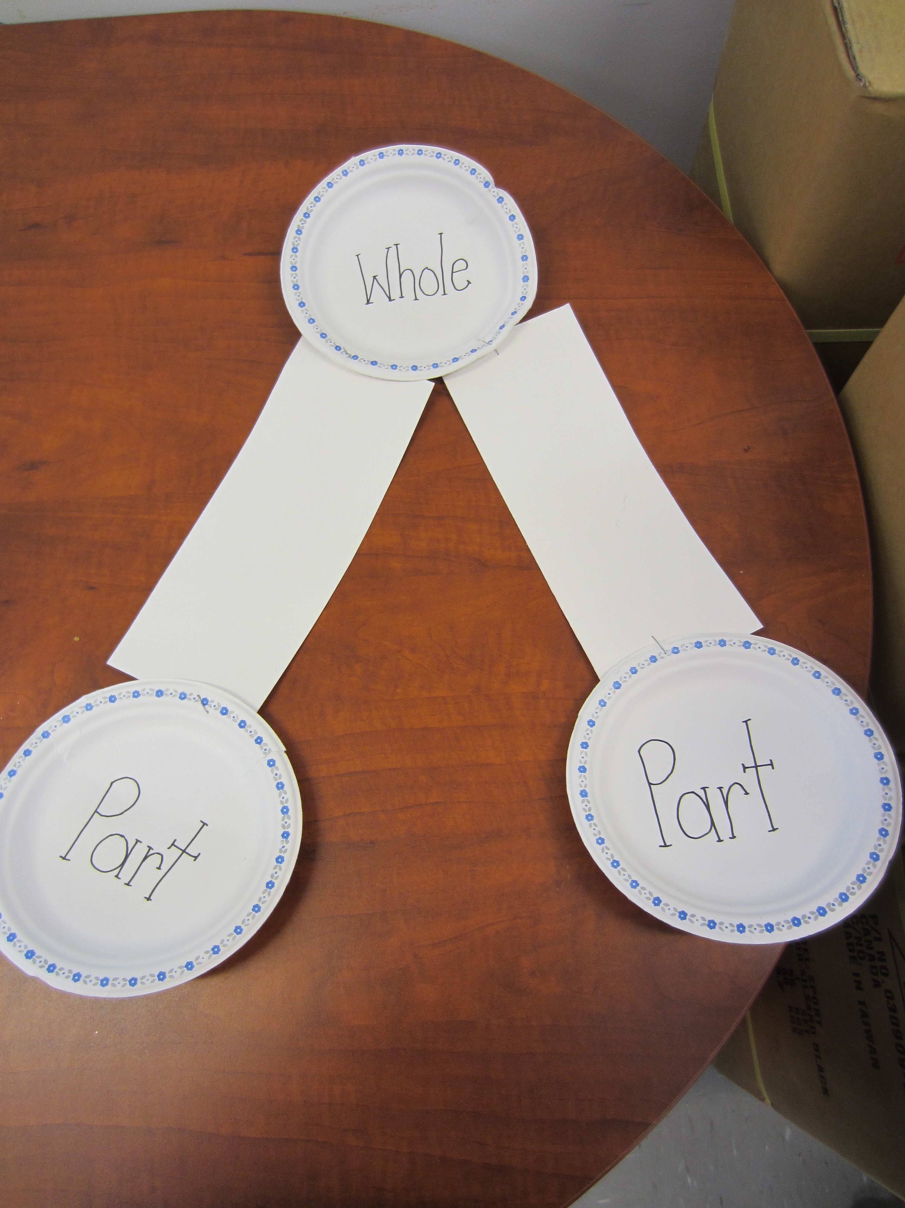

- 10 labelled Ziplock Bags (I let the students do this in pairs ) labelled 1-10 each with a different amount of unifix cubes in them.

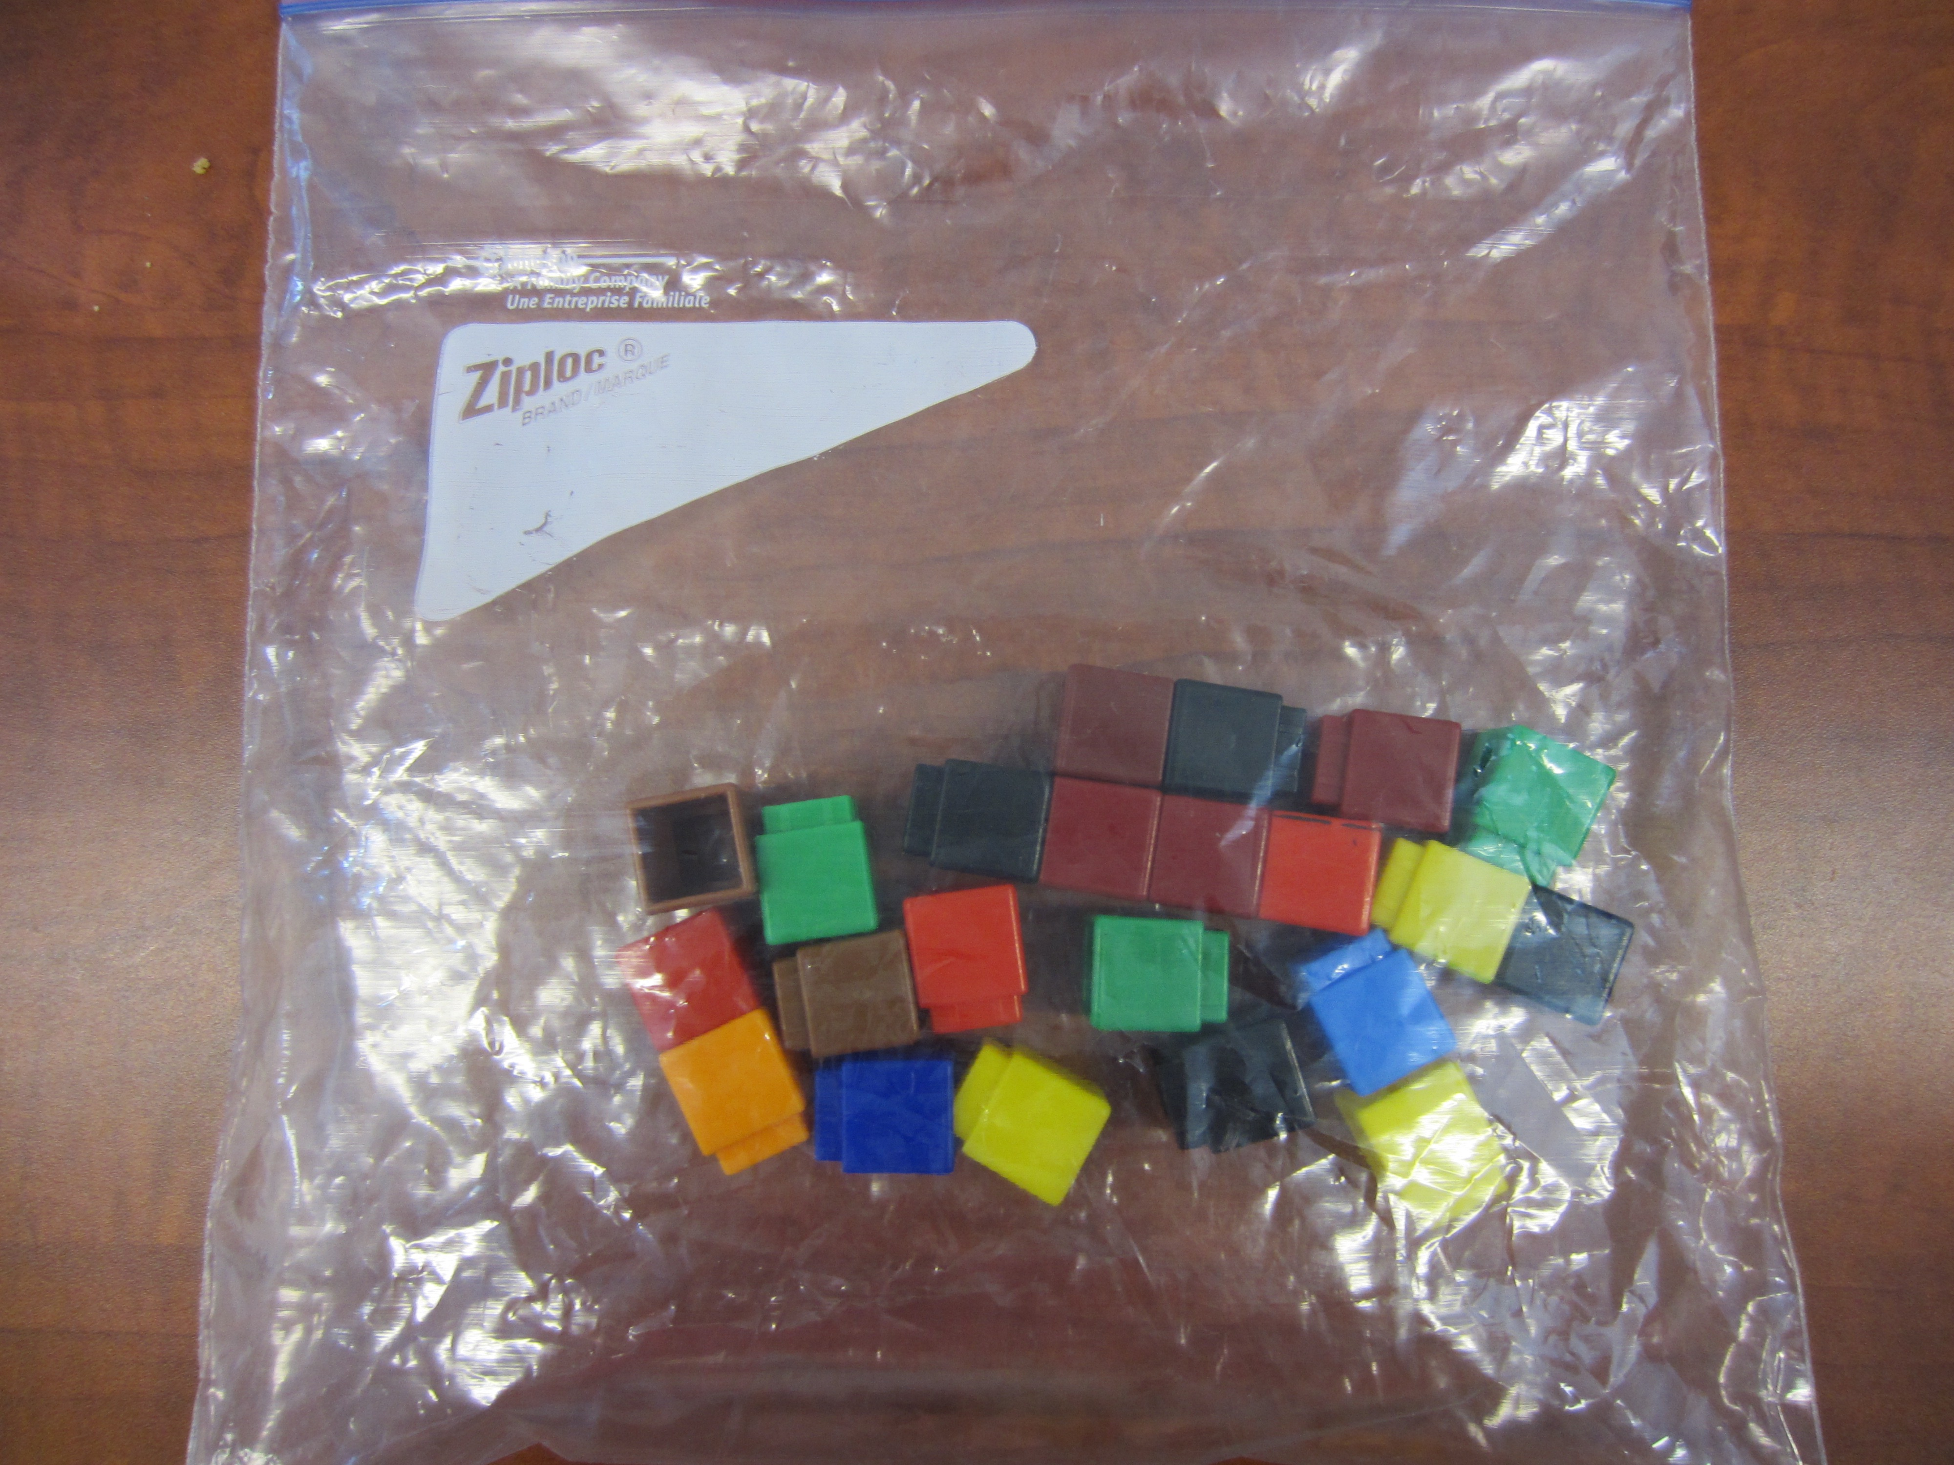

Mental Mathematics

Review addition strategies such as double plus one
Review addition strategies such as adding to 10
Review adding using 0 (ie: 10+0= 10)

Time To Teach

Activate prior knowledge by putting a blank part part whole on the board (I use the smart board for this). In grade one the students should have use part part whole as a strategy when working with numbers to 20. Ask the students if they can explain what this is and how it is used.

If not go through an example- In the top section we put in the whole number in the bottom section we put two numbers that add up to the whole number. The show them how to create a number expression out of that. For example: 22=11+11

Time to Practice

Once students have been given the review explain that they will be working with unifix cubes. Review the expectations of using math manipulatives for math class. We use the manipulatives for learning not playing. If you are playing you will be asked to sit at your desk and work at representing a number using counters instead of with the part part whole racers.

Using an example bag show students how to use the part part whole racer. Starting with the whole number in the whole section. Record the whole number on your recording sheet. Then break your number into two parts and “race” them into the parts section. Record your parts on the recording sheet. Then on the recording sheet create the addition number expression.

Tell students they will be doing this as many times as they can to find different combinations of numbers that equal to their number.

Example of 20 students:

Give one student a part part whole racer
Give another student a unifix cube bag
Either pair them up OR have them find a partner who has the piece they do not

Time to Share

When students have had about 15-20 minutes to work in partners to complete the activity have them share the differnet number expressions they found for their numbers.

Tech Integration

Using the PaperPort Notes App students can take a picture of the part part whole sheet and complete it using the App.
For more information: http://www.paperportnotes.com/
Differentiation

- For students who struggle pair them together with a bag that has less unifix cubes
- For enrichment provide students a bag with a large number

Names: __________________________________ and __________________________________

Part Part Whole Racer Recording Sheet

Whole  Part Part  Number Expression: | Whole  Part Part  Number Expression:
Whole  Part Part  Number Expression: | Whole  Part Part  Number Expression:

